DT 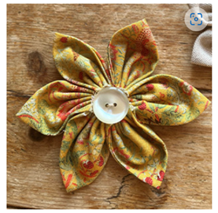
We will be designing, making and evaluating fabric flower badges. We will learn the running stitch.
History
Events beyond living memory – Wright Brothers’ First Flight in 1903. We will learn about early attempts at flight such as hot air balloons and gliders, the Wright brothers’ first powered flight in 1903, Amelia Earhart and Concorde.

English
Our texts this term will be:
The Bear and the Piano
Secret Sky Garden
Non-fiction texts- recounts and fact files
Our grammar learning will include coordinating and subordinating conjunctions, exclamation sentences and questions, expanded noun phrases, use of apostrophes, adverbs and progressive verbs.
RE
We will be exploring how we should care for others and the world through Christianity and Islam. We will learn how these faiths teach that people are valuable and retell stories that guide people to care for each other and our planet.

PE
We will be exploring “Target Games” and “Team Building”.
w

Computing
We will explore "What is a computer?" by learning about computer parts, inputs and outputs, and how computers are used in the world around us.

when creating their own programs.
Special Experiences
21st January- Trip to Slimbridge through the Generation Wild project

Science
We will be exploring the uses of everyday materials including wood, plastic, glass, and metal. Through hands-on investigations and simple tests, we will discover how materials are chosen for different purposes based on their properties, and investigate how some materials can be changed by bending, stretching, squashing and twisting.

Phonics and Spelling
This term, we will focus on spelling patterns and common exception (irregular) words from the Year 2 curriculum, as well as recapping Year 1 phonics and spelling learning. A list of spellings for this term is available on the website class page.
Maths
This term, we will be building strong foundations in Number and Place Value, exploring numbers up to 100 and understanding the value of each digit. In Addition and Subtraction, we'll develop mental maths strategies and learn written methods for two-digit numbers. Our Shape work will focus on identifying properties of 2D and 3D shapes, while in Fractions we'll look at halves and quarters. Throughout all our learning, we'll focus on building confidence and problem-solving skills.

Music
Orchestral instruments (Theme: traditional stories)
PSHE
“Dreams and Goals”

Important Info
- Please read at home at least 5 times a week.
- PE days are Tuesday and Thursday.
- Spelling Quiz is every Monday.
- Reading books are changed every Thursday.
Year Two
Term 3

