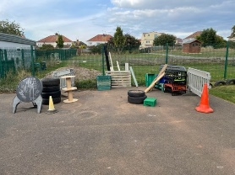
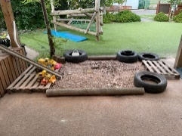
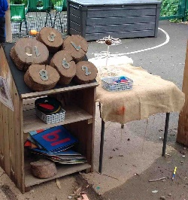
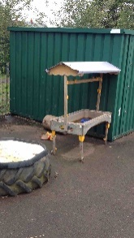
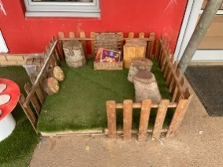
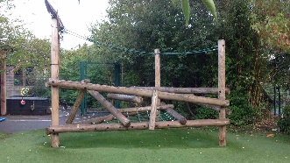
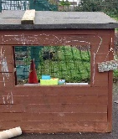
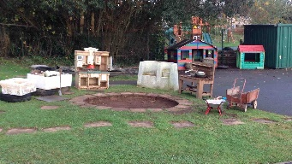
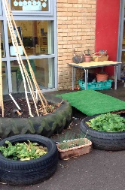
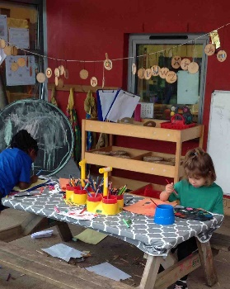

All areas within the outdoor environment enable children to develop their communication and language skills while working with peers and adults alike.
-Listen attentively and respond appropriately during whole class discussions and small group activities
-Make comments about what they have heard and ask questions to clarify their understanding
-Hold conversations when engaged in back and forth exchanges with staff and peers
- Express their ideas and feelings about their experiences using full sentences, including use of past, present and future tenses and make use of conjunctions with modelling support from an adult

All areas within the outdoor environment enable children to develop their Personal and social skills while working with peers and adults alike.
-Show an understanding of their own feelings and those of others, and begin to regulate their behaviour accordingly
-Set and work towards simple goals, being able to wait for what they want and control immediate impulses when appropriate
--Give focused attention to what the teacher says, responding appropriately, even when engaged in activity, and show an ability to follow instruction involving several ideas or actionsBe confident to try new activities and show independence, resilience and perseverance in the face of challenge
-Explain the reason for rules; know right from wrong an try to behave accordingly
-Work and play cooperatively and take turns with others
-Form positive attachments to adults and friendships with peers
-Show sensitivity to their own and to others’ needs

At Barley Close, we understand the importance of children having the chance to have regular opportunities to explore and learn outside. In Reception, we have a large outside area part of which is covered, allowing the children access to the outside in all weathers.
Learning outside supports active healthy lifestyles and give opportunities for energetic physical activity, movement and freedom promoting a sense of wellbeing. It gives the children contact with the natural world and offers them unique outdoor experiences, such as contact with the weather and seasons. Giving learning experiences outside helps the children respect and understand nature and the environment around them.
For many children playing outdoors at school maybe the only opportunity they have to play freely and safely while they learn to assess risk and develop skills to manage new situations.
We look to extend activities in the outside area considering the children’s own interests. We endeavour to support and maximise the rich varied experiences the children gain from being outdoors.
Learning in the outdoor environment reflect the 7 areas of learning in EYFS C and L, Physical, PSED, Literacy, Maths, Understanding the World, Expressive Arts and Design. Outdoor learning is also a good environment to observe and support the characteristics of learning.

