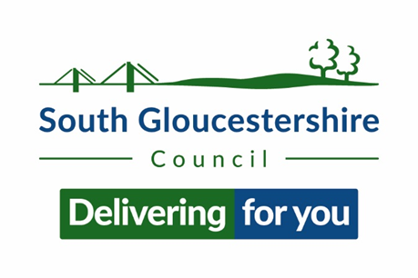
Dear Parent/Guardian
The clocks go back on Sunday 30th October 2022 and South Gloucestershire Road Safety Team will be promoting our Be Bright Be Seen campaign which is available to all schools.
Your child had the opportunity to take part in a Be Bright Be Seen session, by watching and interacting with a presentation, delivered by a member of South Gloucestershire’s Road Safety Team.
The aim of the session is to encourage children to think about the following:
- Being bright
- The difference between Fluorescent and reflective
- Weather
- Safe places to cross

On this sheet we have included an activity for your child to continue the learning experience.

Please encourage your child to wear something bright and take extra care when out and about near roads, especially as nights draw in and visibility is reduced.

Kind Regards
Martina Byrne-Obee
Lead Road Safety Officer
roadsafetyeducation@southglos.go.uk or phone 01454867802
Get creative and design your own style of bright winter clothes


