
Dear Parent/Guardian
The clocks back on Sunday 30th October 2022 and South Gloucestershire Road Safety Team will be promoting our Be Bright Be Seen campaign which is available to all schools.
Your child had the opportunity to take part in a Be Bright Be Seen session, by watching and interacting with a presentation, delivered by a member of South Gloucestershire’s Road Safety Team.
The aim of the session is to encourage children to think about the following:
- Being bright
- The difference between Fluorescent and reflective
- Weather
- Safe places to cross

On the back of this sheet is an activity for your child to continue the learning experience.

Please encourage your child to wear something bright and take extra care when out and about near roads, especially as nights draw in and visibility is reduced.

Kind Regards
Martina Byrne-Obee
Lead Road Safety Officer
roadsafetyeducation or phone 01454 867802
Get creative and design your own style of bright winter clothes
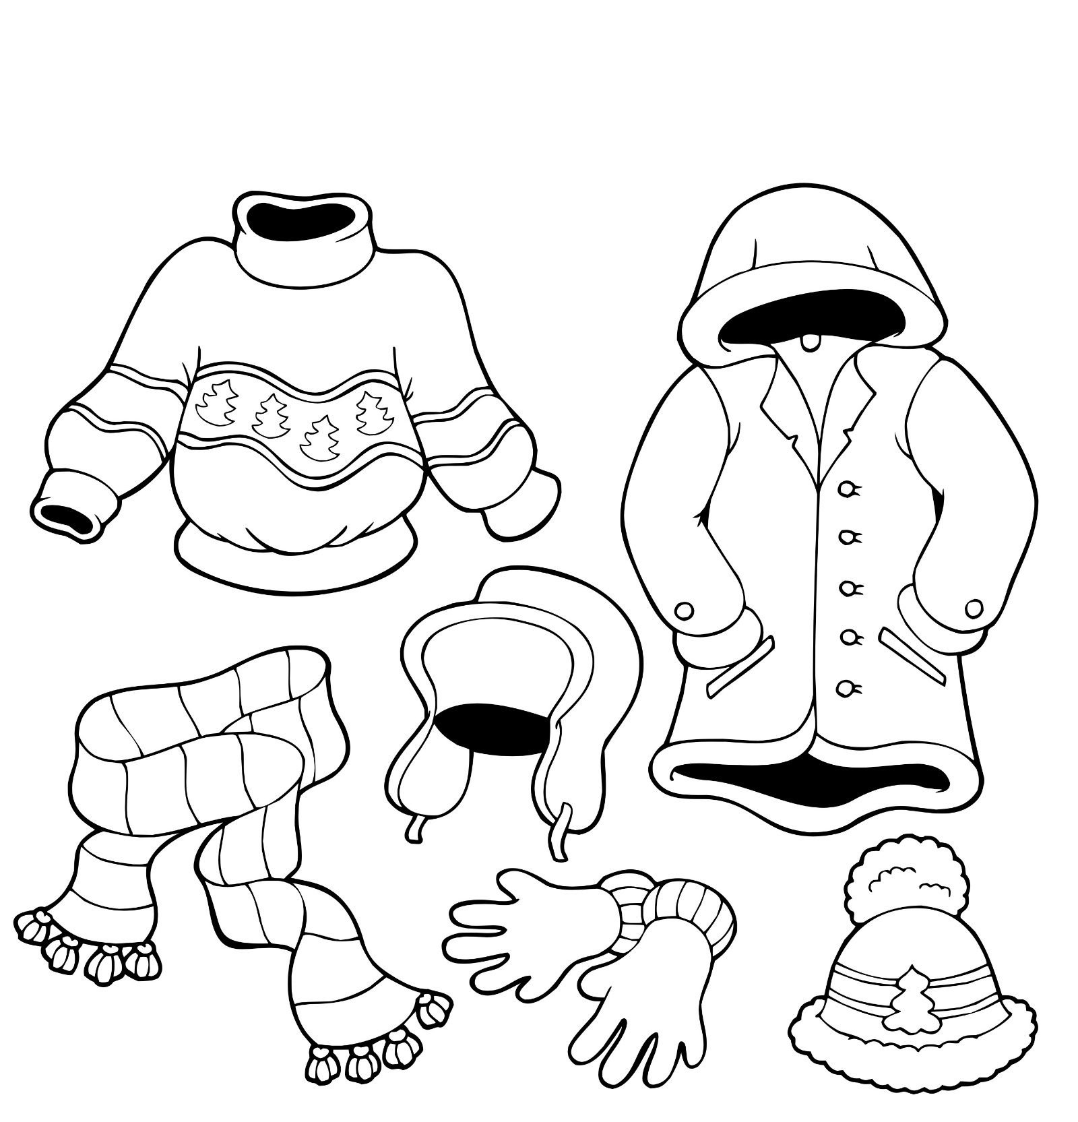


Fill in the Blanks

night | headlights | High | glow | florescent
reflective | fog | drivers | pedestrians | cyclists
lorry | jackets | poor | visibility | ultraviolet
react | refuse | dark | glow | police

H_ _ _ v_ _ _ _ _ _ _ _ _ clothing is clothing made of fluorescent material with added reflective tape or shapes. The sun’s u_ _ _ _ _ _ _ _ _ _ rays r_ _ _ _ with the fluorescent colours to make them appear to g_ _ _ increasing daytime visibility. The effect is stronger in p_ _ _ light conditions such as in f_ _ or towards dusk. At n_ _ _ _, light from sources such as car h_ _ _ _ _ _ _ _ _ bounce off the reflective areas to make the tape glow, increasing night time visibility.
By wearing or carrying something high vis which has both F_ _ _ _ _ _ _ _ _ and r_ _ _ _ _ _ _ _ _ materials, it will help you to be seen day, dusk and night. Florescent for day, reflective for night. On a rainy day it is hard for d_ _ _ _ _ _ to see p_ _ _ _ _ _ __ _ _ _ and c_ _ _ _ _ _ _ so it is a good idea to wear something fluorescent. Many people don’t realise fluorescent colours don’t show up in the d _ _ _ or g _ _ _ in the dark.
Lots of colours can be fluorescent and used for high vis clothing and bags. You have probably seen p_ _ _ _ _ officers, postal workers, l_ _ _ _ drivers and
r_ _ _ _ _ collectors wearing these j_ _ _ _ _ _ .

