07 September 2020
Dear parent/carer
Living Streets’ WOW – the year-round walk to school challenge is back at Barley Close Primary school to help encourage as many children as possible to experience the benefits of walking to school during the 2020-21 school year. The project is being delivered by Living Streets, the UK charity for everyday walking, in association with South Gloucestershire Council and funded by the Department for Transport.
As you know, WOW is a pupil-led initiative where children self-report how they get to school every day. If they travel sustainably (walk, cycle or scoot) three times every week for a month, they get rewarded with a collectable badge at the end of the month. If your family already cycles or scoots to school, these will count towards their WOW badge.
What are the benefits of walking to school? Walking to school helps children feel happier and healthier and even do better in class because they arrive refreshed, fit and ready to learn. And more families walking means less cars on the road during the school run, helping to reduce congestion and pollution at the school gates.
What if you can’t walk to school? If you live too far away or don’t have time to walk the whole way to school, you can Park and Stride to still contribute to getting your WOW badge. Park or hop off public transport at least five to ten minutes away from the school and walk the rest of the way. We have a Park & Stride Zone map on our website.
Is walking to school safe at this time? Walking to school remains an effective way to reduce congestion and improve road safety at the school gates, while increasing physical activity and benefitting pupil wellbeing. The government is actively working with schools and local authorities to encourage families to walk to school whenever they can during this time. However, it is important that measures are in place to protect everyone’s health and are always observed. Living Streets understands that schools face unique challenges at present, which create uncertainty for staff, pupils, and families. We are committed to helping families adapt to changing circumstances, ensuring that everyone involved in our walk to school challenge stays safe.
Did you know? The WOW badges are made using excess yoghurt-pot material previously destined for landfill and are produced in the UK, minimising our carbon footprint. The packaging we use is 100% biodegradable. We’re proud to have found a brilliant use for landfill material!
Thousands of schools and around one million pupils are enjoying the benefits of walking to school across the UK this year so we hope you’ll be joining us! If you have any questions about the programme, please contact Mrs Williams or for more information visit: www.livingstreets.org.uk/WOW
Let’s continue to swap those school runs for school walks.
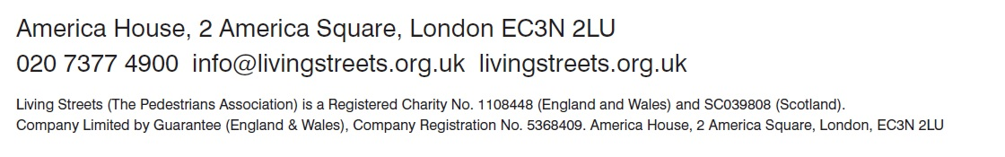
Mrs Jo Williams

