Year 4 Chameleons 2025-2026
 | Term 1 (8 weeks) | Term 2 (7 weeks) | Term 3 (6 weeks) | Term 4 (6 weeks) | Term 5 (5 weeks) | Term 6 (7.2 weeks)
English | “Wolves in the Wall”  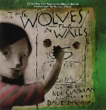  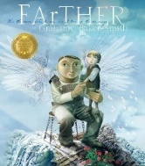  “Farther” | “Kate On The Case”  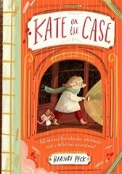 | “Big, Bad Wolf Investigates Fairy Tales”  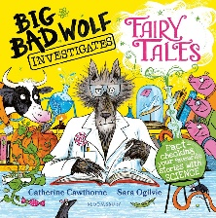 | “The Emerald Forest”  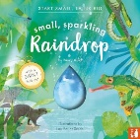  “Small Sparkling Raindrop”  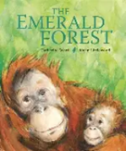 | 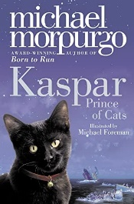  “Kaspar” | “Kensuke’s Kingdom”  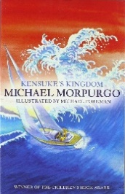
Science | States of Matter | Sound | Electricity | Living things and their habitat | Animals including humans | Science Week
Maths (dripped through the year) | - Number and Place Value  - Statistics  - Fractions, Decimals and Percentages  - Measure  - Geometry
Humanities  History, Geography and RE | Ancient Egypt  What does it mean to be a Hindu in Britain today?  How do family life and festivals show what matters to Jewish people? | UK focus  What does it mean to be a in Sikh Britain today? (Only do this if not doing what does it mean to be a HIndu in Britain today) | The Roman Empire  What can we learn from religions about deciding what is right and wrong? | Map and Fieldwork  Why is Jesus inspiring to some people? | The impact of the Roman Empire on Britain  Why do some people think that life is like a journey and what significant experiences mark this? | Rivers and the Water Cycle  Why do some people think that life is like a journey and what significant experiences mark this?
Art/DT | Art & Design:  Pyramid Sketching- focus on light and shade. | Design & Technology: Pizza  Skill: Cooking | Art & Design:  Exploring Pattern. | Design & Technology:  Skill:  Skill: Fasteners with running stitch. Use a template.  Product: pencil case/ bag/ purse. | Art & Design:  Making Nests | Design & Technology: Lighthouse  Skill: Make an electrical circuit with a bulb- link to Science.  Product: lighthouse.
Music  Kapow Scheme | Body and tuned percussion | Rock and Roll | Changes in pitch, temp and dynamics | Haiku, music and performance | Samba and carnival sounds and instruments | Adapting and transposing motifs
Computing  Kapow Scheme | Computing systems and networks: Collaborative learning | Programming 1: Further coding with scratch | Creating media: Website design | Skills showcase: HTML | Data Handling: Investigating weather | Online safety
PSHE | Being me in my world | Celebrating differences | Dreams and Goals | Healthy Me | Relationships | Changing me
PE: | Striking & Fielding  Netball, Tennis and Cricket - Fielding  Swimming | Invasion Games  Passing & Moving –  Netball and Basketball  Use 6 week plan over 12 weeks - using main Activity and Linked games – highlight as you teach | Invasion Games  Hockey and Football  Dribbling, Movement and teamwork  Gymnastics | Invasion Games  Rugby League  Dance | Net Games  Tennis/Volley  Use 6 session plan over 10 sessions - using main Activity and Linked games – highlight as you teach | Outdoor Adventure  Decisions  Athletics  Record breaking

