
Design & Technology Scheme of Work- Barley Close Community Primary School.

 | Progression in KS1
 | Cooking & Nutrition  (see end of scheme) | Textiles | Structures & Mechanisms | Construction | Key vocabulary
EYFS | Fruit kebab  - Banana  - Strawberries  - Kiwi  - Melon  - Apple/ pear | Delivered through continuous provision and in response to children’s interests. | Delivered through continuous provision and in response to children’s interests. | Delivered through continuous provision and in response to children’s interests.
Y1 | Sandwich  - Bread  - Choice of protein/ cheese  - Cucumber  - Lettuce  - Tomatoes  - Cress | Skill: Use tools and materials to make a paper bag for a story character. Ext: Use weaving.  Product: A paper bag. | Skill: Design and make a moving card with sliders/ levers  Product: A moving card. | Continuous provision:  Select from and use a wide range of materials and construction materials.  Generate, develop, model and communicate ideas through talking, drawing, templates, mock-ups and, where appropriate, information and communication technology. | A paper bag:  structure, shape, strength, handle, base, cut, join, split pin, treasury tag, stiff, weave, link, finish (as in quality of finish), evaluate.  A moving card:  DT, Design, Technology, material, tool, card, fold, slider, lever, in front, behind, left, right, up, down, hinge, evaluate.  Sandwich:  Carbohydrate, protein, salad, vegetable, vitamins, slice, cut, spread, chop, portion, taste, appearance, evaluate.
Y2 | Packed Lunch  - Wrap ingredients  - Snacks, e.g. breadsticks, houmous, soft cheese  - Salad vegetables  - Fruit | Skill: Textile flower using a template.  Product: 3D fabric flower picture. | Skill: Use wheels and axles to make a moving vehicle/ wheelbarrow.  Product: a wheelbarrow (or other vehicle) with moving wheels. |  | Textile flower:  Fabric, template, collage, joining, aesthetic, criteria, structure, petal, style, cutting, shaping, joining, finishing, needle, needle threader, thread, knot, running stitch, mark (template on fabric), embellish.  Moving vehicle:  Wheel, axle, fixing, trial and error, fuction, purpose, audience, joining technique, hacksaw, clamp, bradawl, file, dowelling, stronger, stiffer, stable, smoothing, collage, mechanism.  Packed lunch:  Food groups, dairy, carbohydrates, fruit and vegetables, protein, fats, oils and sugar, balanced diet, nutrition, health and safety, bridge, claw, slice, construct, demonstration, taste, evaluate, nutrition, appearance.

 | Progression in KS2
 | Cooking & Nutrition | Textiles | Structures & Mechanisms | Electrical | Technical Knowledge | Key vocab
Y3 | Greek Salad  - Lettuce  - Tomatoes  - Cucumber  - Peppers  - Olives  - Feta  - Dressing (olive oil, lemon juice, garlic)  - Oregano |  | Skill: Design an earthquake-proof building (link to Geography Skill)  Product: Cardboard building  Skill: Measure, cut and join wood. Skill: Use Gears, Pulleys, Levers.  Product: Marble Maze using a lever to release the marble. Make a Lego prototype. |  |  | Earthquake-proof building:  Cross-section, design, architect, architecture, cut, shape, join, stability, structure, strength, stiffness, construction.  Marble Maze:  Mechanism, prototype, test, design criteria, base, strong, stable, cut, join, shape, lever, function, movement.  Greek salad:  Nutritious, seasonal, seasonality, process (food), fresh, hygienic, contamination, ingredients, varied, nutrition, taste, appearance, evaluate.
Y4 | Pizza  - Dough  - Tomatoes  - Cheese | Skill: Fasteners with running stitch. Use a template.  Product: pencil case/ bag/ purse. |  | Skill: Make an electrical circuit with a bulb- link to Science.  Product: lighthouse. |  | Pencil case:  Product, design, functional, appealing, design criteria, pattern piece, measure, mark, cut, template, running stitch, whip stitch, blanket stitch, fastening, modification, improvement.  Lighthouse:  Lighthouse, structure, stiffen, strengthen, reinforce, circuit, switch, bulb, stable, tool, equipment, cut, shape, join, finish, stability, energy, power, conductor, complete, break, functionality.  Pizza:  Dough, ingredients, budget, seasonal, seasonality, preparation, heatproof, cooking, nutrition, taste, appearance, evaluate.
Y5 | Tuna pasta bake  - Tuna  - Pasta  - Sweetcorn/ Peas  - White sauce (packet/jar)  - Cheese |  | Skill: Use Gears, Pulleys, Levers.  Product: a crane using a pulley system  Skill: Use Cams.  Product: moving toy. |  |  | Crane:  Pulley, forces, strength, gears, levers, mechanism, modify, strength, exploded diagram, force, direction, functional, aesthetic, housing (for the pulley), joints, secure, fixed, moveable.  Moving toy:  Cams, drop, oval, pear circular, movement, annotated sketches, cross-sectional diagrams, develop, refine, scissors, saw, glue gun, ruler, pencil, card, disc, dowel, measure, mark, saw, decorative, sand trim, refine, function.  Pasta bake:  Recipe, adapt, equipment, hob, food hygiene, savoury, taste, smell, texture, appearance, nutrition, evaluate.
Y6 | Plan a healthy balanced meal on a budget. |  |  | Skill: Construction inc. use of tools and an electrical circuit.  Product: choice of windmill, wind turbine OR fairground carousel. | Computer Aided design – Digital World (link to Kapow) | Fairground ride:  Alternative energy, turbine, windmill, design, purpose, blade, structure, annotated sketches, exploded diagrams, prototypes, and computer-aided design.  CAD:  Computer-aided design, stability, structure, stable, weight distribution.  Healthy meal:  Convenience foods, ready-made, processed, salt, home-cooked, budget, evaluate, positives, negatives, modifications, taste, smell, appearance, nutrition, budget, evaluate.

Year 1 | Skill: | Choose from a range of materials and join effectively to make a bag | Explore and use mechanisms- levers and sliders- in a paper product
 | Product: | A bag for a story character | A moving card with sliders/ levers
Prior knowledge |  | EYFS- Speaking: Offer explanations for why things might happen.  EYFS- Fine Motor Skills: Use a range of small tools, including scissors, paint brushes and cutlery.  EYFS- Creating with Materials: Safely use and explore a variety of materials, tools and techniques, experimenting with colour, design, texture, form, and function. | EYFS- Fine Motor Skills: Use a range of small tools, including scissors, paint brushes and cutlery.  EYFS- Creating with Materials: Safely use and explore a variety of materials, tools and techniques, experimenting with colour, design, texture, form, and function.  EYFS- Creating with Materials: Share their creations, explaining the process they have used.
Future learning |  | Year 2: Shaping and joining fabric to make a textile flower.  Year 4: Measuring, cutting and sewing fabric to make a pencil case. | Year 2: Using an axle to create moveable wheels as part of a wheelbarrow.  Year 3: Adding a lever to a marble maze to release the marble.
Skills | Research | ♣Explore a range of bags: what they are for, how they work, materials used, effectiveness for purpose. | ♣ Explore and evaluate a range of existing cards with moving parts.  ♣ Identify strengths and weaknesses of existing product design.
Skills | Design | ♣ Design, individually or in groups with support, a new bag for Stickman/ a story character.  ♣ Use talk or drawings to communicate ideas.  ♣ Develop design criteria. | ♣ Design a card with moving parts- sliders/levers- using research to influence design (could choose Mother’s Day).  ♣ Use research and own experience to inform design.
Skills | Make | ♣ Use a hole punch and scissors to cut and make holes and a stapler to join.  ♣ Use spatulas, glue sticks, masking tape, Sellotape,, split pins and treasury tags.  ♣ Add further materials to make the bag stronger and more stiff.  ♣ Weave with paper.  ♣ Join by linking. | ♣ Use rulers and pencils to mark and score.  ♣ Use spatulas, glue sticks, split pins and treasury tags.
Skills | Evaluate | ♣ Discuss how closely their bag meets their design criteria.  ♣ Identify things that went well and things that could have been better | ♣ Identify strengths and weaknesses of own design.  ♣ Start to talk about changes made during the making process. ♣ Discuss how closely their card meets their design criteria.  ♣ Suggest improvements.
Knowledge | Technical | ♣ Build structures, exploring how they can be made stronger, more rigid and more stable. | ♣ Integrate sliders and levers into picture on card.  ♣ Select materials and resources for a purpose.  ♣ Measure and mark using a template for reference.  ♣ Choose materials to add reinforcement- stiffer and stronger.  ♣ Use templates.
Knowledge | Additional
Continuous provision links |  | Use a range of resources to build.  Create structures for a purpose.  Manipulate playdough to create models.  Use tools to make marks- use scissors to cut continuous straight/ curved lines.  Unwind and stick using Sellotape (find the end). | Use scissors to cut continuously, turning the paper.  Accurate folding including concertina fold.  Thread through holes.  Use hammers/ screwdrivers.  Use a range of tools to shape clay.  Elaborate and add decoration to models.

Year 2 | Skill: | Explore and use mechanisms [wheels and axles] to make a moving vehicle | Select from and use a wide range of materials and components, including construction materials, textiles and ingredients, according to their characteristic
 | Product: | Wheelbarrow | Textile flower
Prior knowledge |  | EYFS- Fine Motor Skills: Use a range of small tools, including scissors, paint brushes and cutlery.  EYFS- Creating with Materials: Safely use and explore a variety of materials, tools and techniques, experimenting with colour, design, texture, form, and function.  Year 1: Adding sliders and levers to greetings cards to add movement. | EYFS- Fine Motor Skills: Use a range of small tools, including scissors, paint brushes and cutlery.  EYFS- Creating with Materials: Safely use and explore a variety of materials, tools and techniques, experimenting with colour, design, texture, form, and function.  Year 1: Cutting and joining paper to make a bag.
Future learning |  | Year 5: Use pulleys to make a crane system (moving mechanisms).  Year 5 (cranes): Understand how pulleys change the direction of a force.  Year 5: Use cams to make moving toys (moving mechanisms). | Year 4: Measuring, cutting and sewing fabric to make a pencil case.
Skills | Research | ♣ Evaluate a range of real and toy wheelbarrows and other related objects with wheels and axles.  ♣ Understand advantages and disadvantages of different fixings for wheels and axles.  ♣ Model ideas by exploring materials / components and by adjusting ideas through trial and error. | ♣ Model ideas by exploring a range of fabrics and by making templates.  ♣ Explore and evaluate a range of fabric flowers- brooches, collage.  ♣ Discuss how the fabrics have been joined/ which are the most successful/ aesthetically appealing and why?
Skills | Design | ♣ Create design criteria for a mode of transport to include wheels / axles. Show an understanding of function / purpose and audience.  ♣ Communicate ideas through drawing / writing justifying choices made for material types and joining techniques. | ♣ Create design criteria for 3D fabric flower picture.  ♣ Communicate ideas through drawing / writing, justifying choices made for fabric styles and colours/ petal shapes.
Skills | Make | ♣ Select from and use a range of tools and equipment to perform practical tasks [for example, cutting, joining and finishing]: hacksaws, clamps, bradawl (hole maker), rulers to measure, scissors, files to smooth.  ♣ Measure, mark and cut using scissors / saws/ pierce holes with bradawls  ♣ Fix wooden doweling into clamps.  ♣ Join materials together using a range of techniques.  ♣ Explore and use wheels and axles, finding appropriate ways to fix these together and onto models- fixed or moving axles.  ♣ Find ways of making parts stronger/ stiffer or more stable  ♣ Use finishing techniques- smoothing, filing, paint, collage | ♣ Select from and use a range of tools and equipment to perform practical tasks [for example, cutting, shaping, joining and finishing]: needles, needle threaders, fabric scissors, fabric glue, threads.  ♣ With support, knot thread, thread needle and sew using basic running stitch.  ♣ With support, measure, mark out, cut and shape fabric pieces.  ♣ Use finishing techniques – stuffing and embellishing using fabric glue.
Skills | Evaluate | ♣ Explain changes made during the making process.  ♣ Evaluate effectiveness of finished product.  ♣ Suggest further improvements | ♣ Identify positive elements of their product.  ♣ Highlight areas for improvement.
Knowledge | Technical | ♣ Explore and use mechanisms [wheels and axles] in their products.
Knowledge | Additional

Year 3 | Skill: | Design an earthquake-proof building (link to Geography Skill) | Measure, cut and join wood. Skill: Use gears, pulleys and levers.
 | Product: | Cardboard earthquake-proof building | Marble Maze using a lever to release the marble. Make a Lego prototype.
Prior knowledge |  | EYFS- Speaking: Offer explanations for why things might happen.  Year 1: Cutting and joining paper to make a bag.  Year 2 (wheelbarrow): Communicate ideas through drawing / writing justifying choices made for material types and joining techniques.  Year 2 (wheelbarrow): Select from and use a range of tools and equipment to perform practical tasks [for example, cutting, joining and finishing]: hacksaws, clamps, bradawl (hole maker), rulers to measure, scissors, files to smooth. | Year 1: Adding a lever to a greetings card to add movement.  Year 2 (wheelbarrow): Select from and use a range of tools and equipment to perform practical tasks [for example, cutting, joining and finishing]: hacksaws, clamps, bradawl (hole maker), rulers to measure, scissors, files to smooth.  Year 2 (wheelbarrow): Measure, mark and cut using scissors / saws/ pierce holes with bradawls
Future learning |  | Year 4 (lighthouse): To learn the importance of stiffening, strengthening and reinforcing structures.  Year 4 (lighthouse): To create a stable structure.  Year 5 (cranes): Use the views of others to improve designs. | Year 4: To know that creating a template of their design is useful.  Year 5 (cranes): Use the views of others to improve designs.  Year 5 (cranes): Use pulleys to make a crane system (moving mechanisms).  Year 5 (moving toys): Use cams to make moving toys (moving mechanisms).
Skills | Research | ♣ Use research and develop design criteria to inform the design of innovative, functional, appealing products that are fit for purpose, aimed at particular individuals or groups. | ♣ Use research and develop design criteria to inform the design of innovative, functional, appealing products that are fit for purpose, aimed at particular individuals or groups.  ♣ Analyse a selection of existing children’s mazes.  ♣ Understand that some real-life games contain mechanisms.
Skills | Design | ♣ Generate, develop, model and communicate their ideas through discussion, annotated sketches and cross-sectional diagrams. | ♣ Generate, develop, model and communicate their ideas through discussion, annotated sketches and prototypes (use Lego).  ♣ To explore how prototypes can be used to test design ideas.
Skills | Make | ♣ Select from and use a wider range of tools and equipment to perform practical tasks [for example, cutting, shaping and joining] accurately. | ♣ To be able to create a base that is strong and stable.  ♣ Select from and use a wider range of tools and equipment to perform practical tasks [for example, cutting, shaping and joining] accurately.  ♣ Decorate the board game to a high-quality finish.  ♣ Understand and use mechanical systems in their products - levers (release the marble).
Skills | Evaluate | ♣ Explore the features of earthquake-proof structures.  ♣ Compare the stability of different structures.  ♣ Consider the views of others to improve their work. | ♣ Testing your own game and other finished games, evaluating against the design criteria.  ♣ Identifying what went well and suggesting how we can improve the game.  ♣ Consider the views of others to improve their work.
Knowledge | Technical | ♣ To recognise that wide and flat-based objects are more stable.  ♣ To explore the importance of strength and stiffness in structures. | ♣ To understand and use a mechanical system in their product – lever.  ♣ To understand that a lever is a mechanism that can control movement.
Knowledge | Additional | ♣ To apply the knowledge that a building needs to be strong and stable to withstand natural disasters.  ♣ To use a list of design criteria for a construction project. | ♣ To apply the knowledge that the marble needs to stay enclosed on the board.  ♣ To test their design as they go along so they can solve any problems that may occur.

Year 4 | Skill: | Fasteners with running stitch. Use a template. | Make an electrical circuit with a bulb- link to Science.
 | Product: | Pencil case/ bag/ purse. | Lighthouse.
Prior knowledge |  | Year 1: Cutting and joining paper to make a paper bag.  Year 2: Shaping and joining fabric to make a textile flower. | Year 3 (earthquake-proof buildings): Compare the stability of different structures.  Year 3 (earthquake-proof buildings): Select from and use a wider range of tools and equipment to perform practical tasks [for example, cutting, shaping and joining] accurately.
Future learning |  | Year 6: Revisit research findings and design ideas. | Year 6 (fairground ride): Create a simple circuit including a switch and a motor attached to fan blades.  Year 6 (fairground ride): Create a stable structure, thinking about weight distribution.
Skills | Research | ♣ Investigate and analyse a range of existing products.  ♣ Use research to inform the design of functional, appealing products that are fit for purpose. | ♣ Research different lighthouses by purpose and design features.
Skills | Design | ♣ Write design criteria for their end product, articulating decisions made.  ♣ Generate, develop, model and communicate their ideas through discussion, annotated sketches and pattern pieces. | ♣ Write design criteria for their end product, articulating decisions made.  ♣ To learn the importance of stiffening, strengthening and reinforcing structures.
Skills | Make | ♣ Measure, mark and cut fabric using a paper template.  ♣ Select a stitch style to join fabric from: running stitch, whip stitch and blanket stitch.  ♣ Work neatly by sewing small, straight stitches.  ♣ Incorporate a fastening to a design, e.g. a button. | ♣ Create a simple circuit including a switch and a bulb.  ♣ To create a stable structure.  ♣ Select from and use a wide range of tools and equipment to perform practical tasks: cutting, shaping, joining and finishing.
Skills | Evaluate | ♣ Evaluate the end product against the design criteria, deciding how many have been met.  ♣ Suggest modifications or improvements. | ♣ Compare the stability of different shapes and joins.  ♣ Identify the weakest part of the structure and the stability of their own structure.  ♣ Evaluate the electrical circuit- does the bulb light up?
Knowledge | Technical | ♣ To know that a fastening is something that holds two pieces of material together.  ♣ To recognise the different stitch styles and the advantages and disadvantages of each. | ♣ To know that a battery contains energy that can power products.  ♣ To understand that electrical conductors are materials which electricity can pass through.  ♣ To know that an electrical circuit must be complete for electricity to flow.  ♣ To know that a switch can be used to complete and break an electrical circuit.
Knowledge | Additional | ♣ To know that creating a template of their design is useful. | ♣ To know facts from the history and functionality of lighthouses.

Year 5 | Skill: | Use Gears, Pulleys, Levers. | Use Cams.
 | Product: | A crane using a pulley system. | Moving toy.
Prior knowledge |  | Year 2: Using an axle to create moveable wheels as part of a wheelbarrow.  Year 4 (lighthouse): To learn the importance of stiffening, strengthening and reinforcing structures.  Year 4 (lighthouse): To create a stable structure. | Year 2: Using an axle to create moveable wheels as part of a wheelbarrow.
Future learning |  | Year 6 (fairground ride): To know that materials can be manipulated to affect functionality.
Skills | Research | ♣Learn that different types of drawings are used in design to explain ideas clearly, e.g. exploded diagram.  ♣ Evaluate the strengths of efficient pulley mechanisms and the weaknesses of poor designs. | ♣ Experiment with a range of cam examples (drop, oval, pear circular) to explore different movements they create.  ♣ Make observations of how cams work and research everyday use.
Skills | Design | ♣ Develop design criteria from a design brief.  ♣ Design a mechanism using a pulley system.  ♣ Understand how pulleys change the direction of a force. | ♣ Generate a toy design that incorporates a cam for movement with clear audience and purpose.  ♣ Communicate design through annotated sketches and cross-sectional diagrams.  ♣ Develop and refine designs through peer discussion.
Skills | Make | ♣ Select materials due to their functional and aesthetic characteristics.  ♣ Build secure housing for a pulley system.  ♣ Measure, mark and cut components accurately using a ruler and cutting tools.  ♣ Understand that for the frame to function effectively, the components must be measured and cut accurately and the joints secured properly. | ♣ Select tools, equipment and materials (scissors, saw, glue gun, ruler, pencil, card, wooden discs and cams, dowel)  ♣ Measure, mark and saw the mechanism components accurately.  ♣ Make cam mechanisms ensuring smooth movement.  ♣ Assemble range of additional decorative components.  ♣ Apply finishing techniques with purpose and audience in mind (sanding, trimming, refining).
Skills | Evaluate | ♣ Use the views of others to improve designs.  ♣ Test and modify the design, suggesting improvements.  ♣ Describe changes they would make if they were to do the project again. | ♣ Evaluate the work of others and receive feedback on own work.  ♣ Evaluate ideas and products against their own design criteria.  ♣ Apply points of improvement to own work.
Knowledge | Technical | ♣ To understand how a pulley system works.  ♣ Learn that a pulley can be fixed or moveable and research where both might be used. | ♣ Understand what a cam is and its key function.  ♣ Understand the purpose of a cross-sectional diagram and how it shows the inner workings of a product’s mechanism.
Knowledge | Additional

Year 6 | Skill: | Computer-aided design – Digital World (CAD) | Construction inc. use of tools and an electrical circuit.
 | Product: | Choice of windmill, wind turbine OR fairground carousel (wooden base with card blades to enable design exploration). | Choice of windmill, wind turbine OR fairground carousel (wooden base, card blades to enable design exploration).
Prior knowledge |  | N/A- this is the first use of CAD. | Year 4 (lighthouse): To learn the importance of stiffening, strengthening and reinforcing structures.  Year 4 (lighthouse): To create a stable structure.  Year 4 (lighthouse): Create a simple circuit including a switch and a bulb.  Year 5 (cranes): Select materials due to their functional and aesthetic characteristics.
Future learning |  | N/A | N/A
Skills | Research | ♣ Research alternative energy.  ♣ Research wind turbine/ windmill design and purpose.  ♣ Research the effect of different blade shapes and designs.
Skills | Design | ♣ Generate, develop, model and communicate their ideas through discussion, annotated sketches, exploded diagrams, prototypes, and computer-aided design (CAD).  ♣ Explore the features of structures (including the blades). | ♣ Revisit research findings and design ideas.  ♣ Test the stability of different structures.  ♣ To know that materials can be manipulated to affect functionality.
Skills | Make |  | ♣ Create a simple circuit including a switch and a motor attached to fan blades.  ♣ Create a stable structure, thinking about weight distribution.  ♣ Select from and use a wide range of tools and equipment to perform practical tasks: cutting, shaping, joining and finishing.  ♣ Safely use a saw to cut a wooden base for the structure.  ♣ Apply research findings to produce functionally effective fan blades.
Skills | Evaluate |  | ♣ Evaluate their ideas and products against their own design criteria.  ♣ Evaluate the feedback of others and receive feedback on own work.  ♣ Apply points of improvement to own work.
Knowledge | Technical |  | ♣ To know that a battery contains energy that can power products.  ♣ To understand that electrical conductors are materials which electricity can pass through.  ♣ To know that an electrical circuit must be complete for electricity to flow.  ♣ To know that a switch can be used to complete and break an electrical circuit.
Knowledge | Additional

Examples of finished products:
Year 1  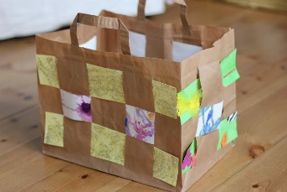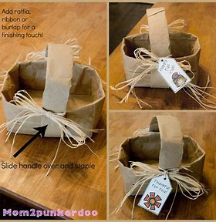  Woven paper bag-  challenge extension  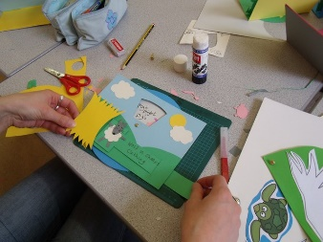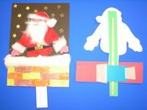  Moving cards |  |  | Year 2  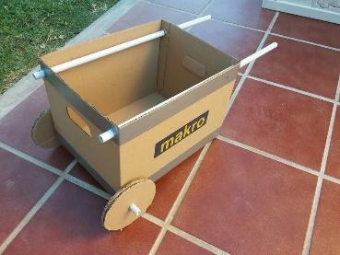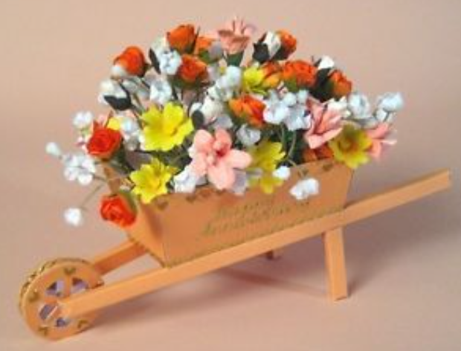  Moving vehicle- wheelbarrow  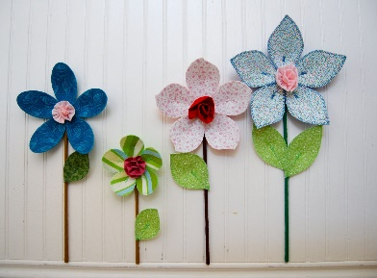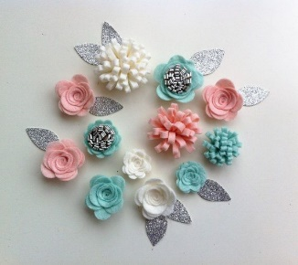  3D Fabric flowers |  | Year 3  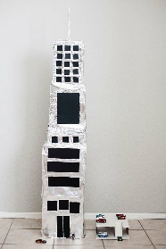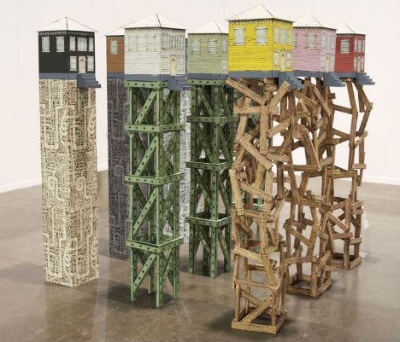  Earthquake-proof buildings  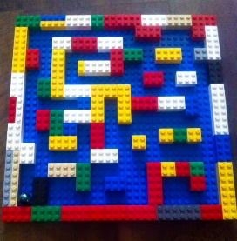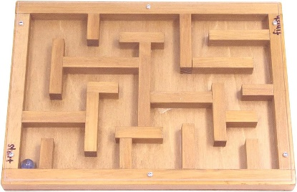  Marble run Lego prototype and final wooden maze
Year 4  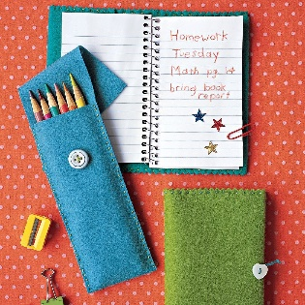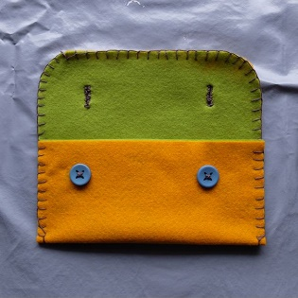  Pencil case/ bag/ purse  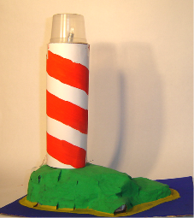  Lighthouse |  |  | Year 5  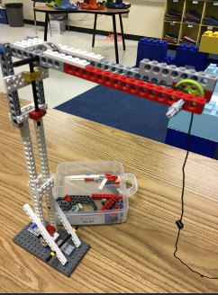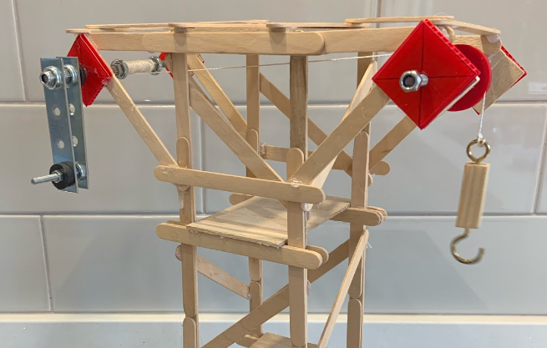  Crane using a pulley system  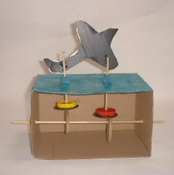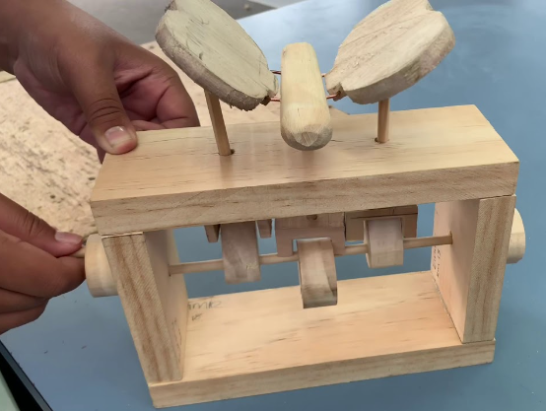  Moving toy with cams |  | Year 6  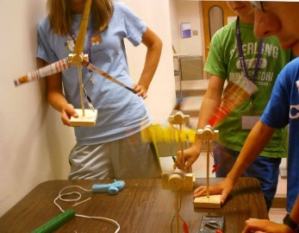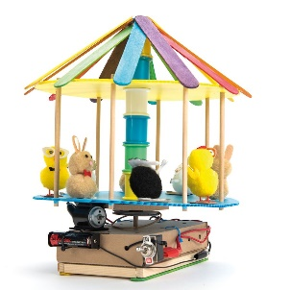  Choice of windmill, wind turbine or fairground ride/ carousel
Cooking and Nutrition |  | Year 1 |  | Year 2
 | Recipe: | Sandwich |  | Packed Lunch
 | Ingredients: | Bread  Choice of protein/ cheese  Cucumber  Lettuce  Tomatoes  Cress |  | Wrap ingredients  Snacks, e.g. breadsticks, houmous, soft cheese  Salad vegetables  Fruit
Prior knowledge
Future learning
Skills | Design | ♣ Design a tasty and nutritious sandwich.  ♣ Select a range of healthy ingredients covering several food groups. |  | ♣ Plan a healthy and delicious packed lunch, considering where the ingredients come from.  ♣ Plan to incorporate all five food groups.
Skills | Make | ♣ Grow cress to put in our sandwiches.  ♣ Slice vegetables safely, with support. |  | ♣ Slice vegetables safely using a bridge or claw grip.  ♣ Construct a wrap that meets a design brief.
Skills | Evaluate | ♣ Describe the taste, texture and smell of the ingredients.  ♣ Evaluate their sandwich, considering taste and appearance.  ♣ Describe the information that should be included on a label. |  | ♣ Taste-test food combinations and final products.  ♣ Evaluate which grip was most effective.  ♣ Evaluate their packed lunch, considering nutrition, taste and appearance.
Knowledge | Cooking/ Nutrition | ♣ Use the basic principles of a healthy and varied diet to prepare dishes. |  | ♣ Use the basic principles of a healthy and varied diet to prepare dishes.  ♣ Understand where food comes from.

Cooking and Nutrition |  | Year 3 | Year 4 | Year 5 | Year 6
 | Recipe: | Greek Salad | Pizza | Tuna pasta bake | Plan a healthy balanced meal on a budget.
 | Ingredients: | Lettuce  Tomatoes  Cucumber  Peppers  Olives  Feta  Dressing (e.g. olive oil, lemon juice, garlic)  Oregano | Dough  Tomatoes  Cheese  Choice of topping to cover a range of food groups | Tuna  Pasta  Sweetcorn/ Peas/ Mushrooms  White sauce (packet/jar)  Cheese | N/A  This unit focuses on the life skill of being able to plan a meal creatively whilst sticking to a set budget.
Prior knowledge
Future learning
Skills | Design | ♣ Create a healthy and nutritious recipe for a Greek salad using seasonal ingredients. | ♣ Design a pizza, using given ingredients and budget.  ♣ Consider seasonal vegetable toppings and the benefits of growing our own. | ♣ Adapt a traditional recipe, understanding this may alter the nutritional value (e.g. by using a jar of sauce). | ♣ Adapt a recipe based on research.  ♣ Include facts and drawings/ photographs from research undertaken.
Skills | Make | ♣ Prepare themselves for hygienic food preparation, learning the basic rules to avoid food contamination.  ♣ Wash, slice and chop ingredients safely. | ♣ Prepare themselves and a work space to cook safely in.  ♣ Follow instructions within a recipe, including preparation of ingredients.  ♣ To know it is important to use oven gloves when removing hot food from an oven. | ♣ Use equipment safely, including knives, hot pans and hobs.  ♣ Follow instructions within a recipe.  ♣ Cook safely, following basic food hygiene rules. | ♣ Write a recipe, explaining the ingredients, key steps and method.  ♣ Calculate the cost of a meal using current price information.
Skills | Evaluate | ♣ Evaluate their salad, considering nutrition, taste and appearance.  ♣ Describe the benefits of seasonal fruit and vegetables and the impact on the environment | ♣ Evaluate their pizza, considering nutrition, taste and appearance.  ♣ Suggest points for improvement when making a pizza. | ♣ Evaluate a recipe, considering: nutrition, taste, smell, texture and appearance. | ♣ Suggest modifications to a recipe based on taste, smell, appearance, nutrition or budget.
Knowledge | Cooking/ Nutrition | ♣ Understand and apply the principles of a healthy and varied diet.  ♣ Understand seasonality, and know where and how a variety of ingredients are grown and processed. | ♣ Understand seasonality, and know where and how a variety of ingredients are grown, reared, caught and processed. | ♣ Prepare and cook a variety of predominantly savoury dishes using a range of cooking techniques. | ♣ To learn how to feed themselves and others affordably and well, now and in later life.

