Barley Close Community Primary School – PSHE Curriculum (PSED for Foundation Stage)
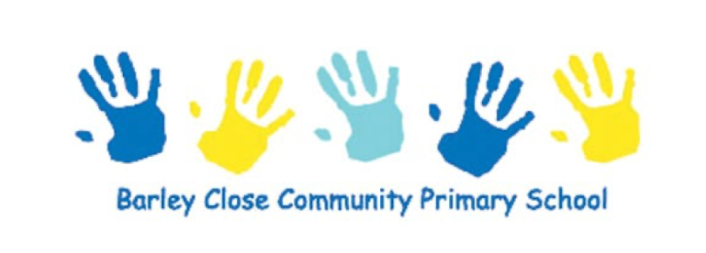
Intent

At Barley Close Community Primary School, PSHE enables our children to become independent, confident, healthy and responsible members of society, as well as developing the “whole child” intellectually, morally, socially and spiritually. Our curriculum has a strong emphasis on emotional literacy, building resilience and nurturing mental and physical health. Through our whole-school approach to PSHE, it is our belief that tackling these issues (which are part of growing up), will lead to happy, confident learnings and therefore excellence across the curriculum and beyond in later life. PSHE is taught across the school from EYFS - Year 6 on a weekly basis and as a school, we follow the Jigsaw PSHE scheme.

Our PSHE curriculum gives children access to a relevant and meaningful PSHE curriculum, which is supported through a strong emphasis on emotional literacy, building resilience and nurturing mental and physical health. We aim to be able to provide our children with a strong understanding of the diverse world around them and support them in playing a positive role in contributing to the school and the wider community. Weaving through the heart of our PSHE teaching, is a commitment to enhancing and promoting our core values;
- Kindness
- Curiosity
- Respect

Implementation

Our whole curriculum is shaped by our school vision which aims to enable all children, regardless of background, ability, additional needs, and to flourish to become the very best version of themselves they can possibly be. We teach the National Curriculum, supported by a clear skills and knowledge progression. This ensures that skills and knowledge are built on year by year and sequenced appropriately to maximise learning for all children. Jigsaw PSHE directs our aim on developing the “whole child” through a spiral curriculum approach.

The over-riding aim of JIGSAW is to provide children with age-appropriate, sensitive emotional literacy by allowing children to build their resilience and by nurturing mental and physical health. Jigsaw equips us to deliver engaging and relevant PSHE within a whole-school approach. Jigsaw lessons all include mindfulness and this allows children to advance their emotional awareness, concentration and focus.

Jigsaw combines PSHE, emotional literacy, mindfulness, social skills and spiritual development. Jigsaw is designed as a whole school approach, with all year groups working on the same theme (Puzzle) at the same time. Jigsaw aims to help children know and value who they really are and how they relate to other people in this ever-changing world. There are six Puzzles (half-term units of work) each with six Pieces (lessons). Every year group studies the same Puzzle at the same time (sequentially ordered from September to July.) Each year group is taught one lesson per week and all lessons are delivered in an age- and stage-appropriate way so that they meet children’s needs. The different puzzle pieces are:

Term 1 Being Me
Term 2 Celebrating Difference
Term 3 Dreams and Goals
Term 4 Healthy Me
Term 5 Relationships
Term 6 Changing Me (RSE included
Impact
- Less children with low self-esteem and better equipped to be resilient within a modern society.
- Children are better aware of social media; how to be safe, utilise this productively and make good choices.
- Children will have had opportunities to fail, as well as discuss why failure is important, so that they are more resilient to failure and view this as a positive.
- Children will collaborate critically, creatively and with a caring approach throughout their time in school.
- Children are able to reflect on their behaviour and evaluate what good behaviour and a good learner should look like. This will allow children to learn from bad choices.
- Our children will be happy and encouraging of others in and out of the classroom.
- Children leave the school with a sense of belonging where they have the confidence and skills to make decisions, self-evaluate, make connections and become lifelong learners.

