PROGRESSION | MULTIPLICATION | DIVISION
Reception | Make it  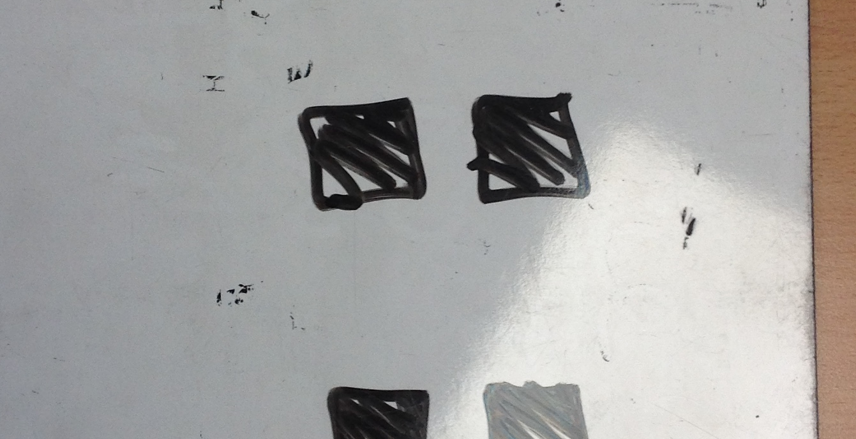  2 + 2 + 2 = 6 | Make it – with objects  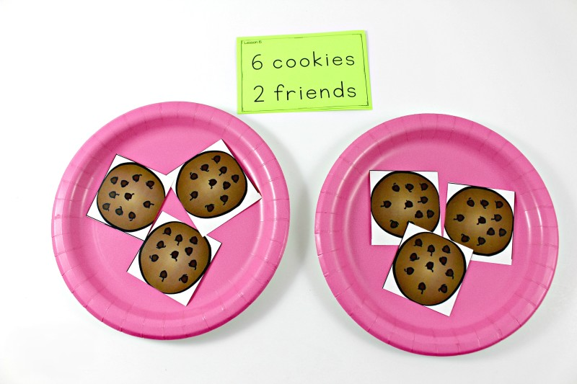
Year 1 | Pictorial representation – groups of  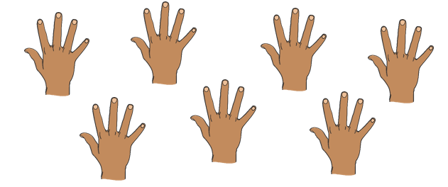 7 groups of 5= 35  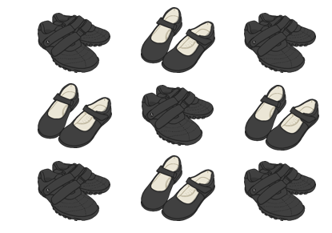  9 groups of 2 =  Number sequences  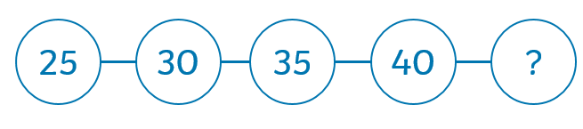  Arrays  Make it  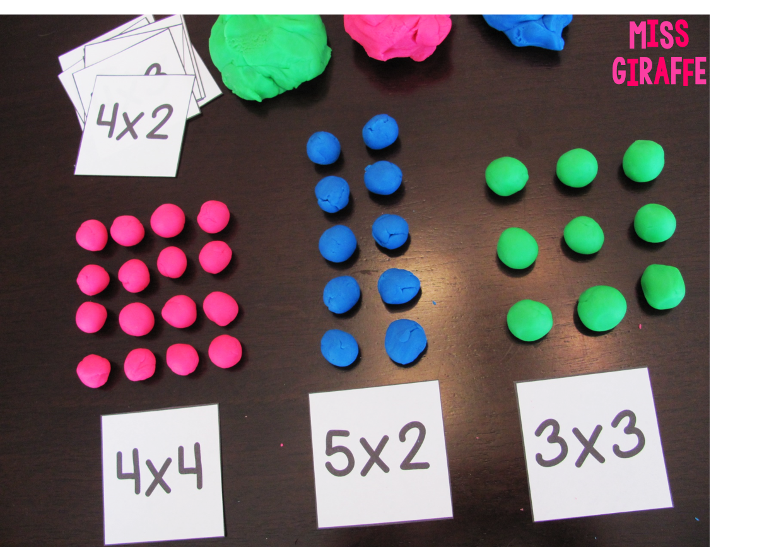  Draw it  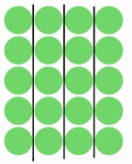  Write it  5 x 4=20  Make it - Using arrays to understand multiplication  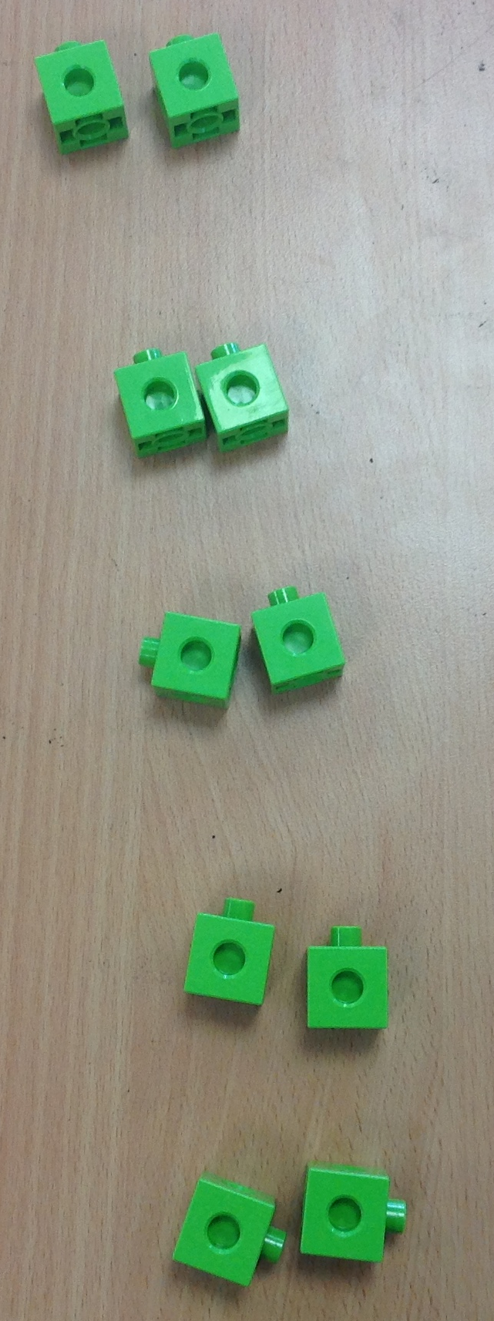  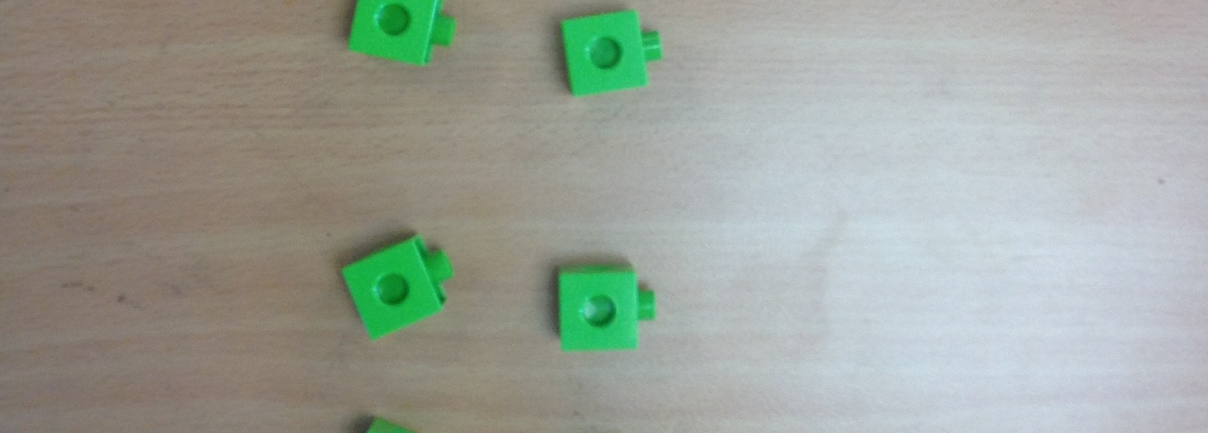  5 x 2 = 10  2 x 5 = 10  Draw it - Repeated addition  4 x 5 = 5 + 5 + 5 + 5 = 20  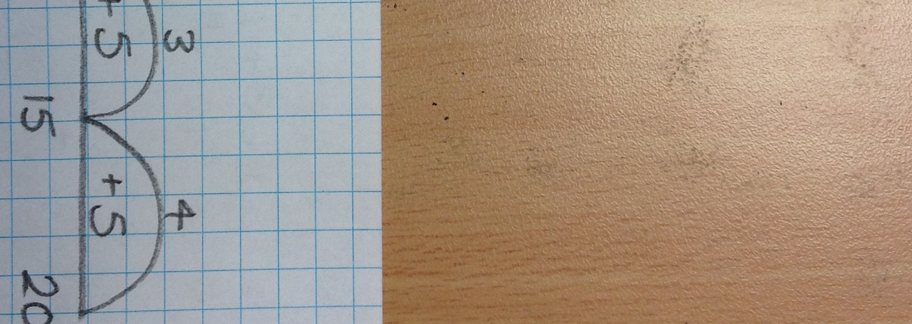  because of communicative law…  5 X 4 = 4 + 4 + 4 + 4 + 4 = 20  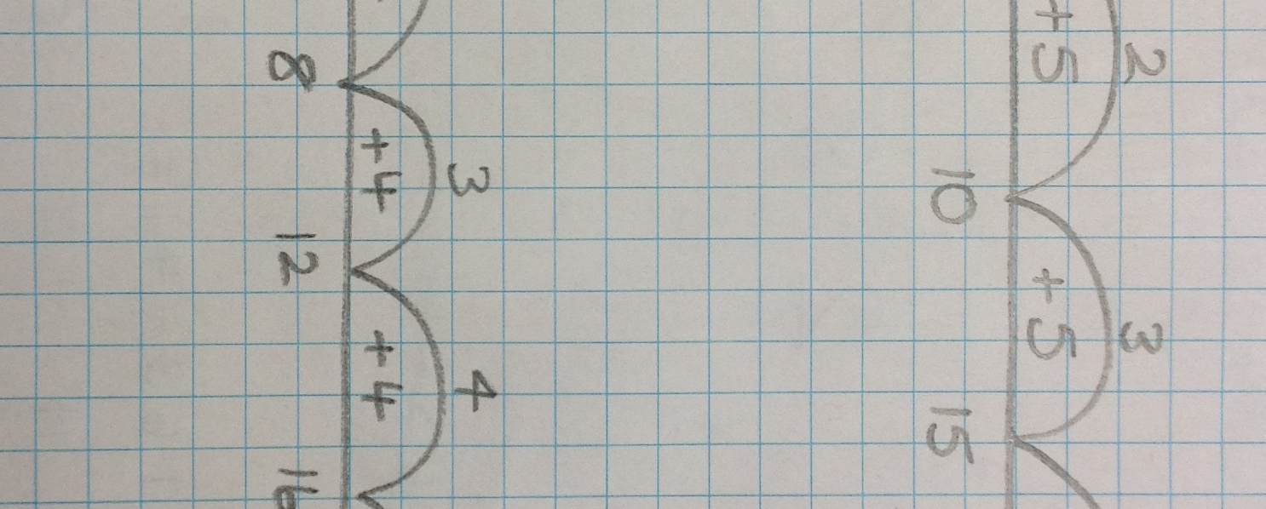  ALWAYS WRITE HOW MANY GROUPS ARE BEING ADDED | Pictorial representation – sharing  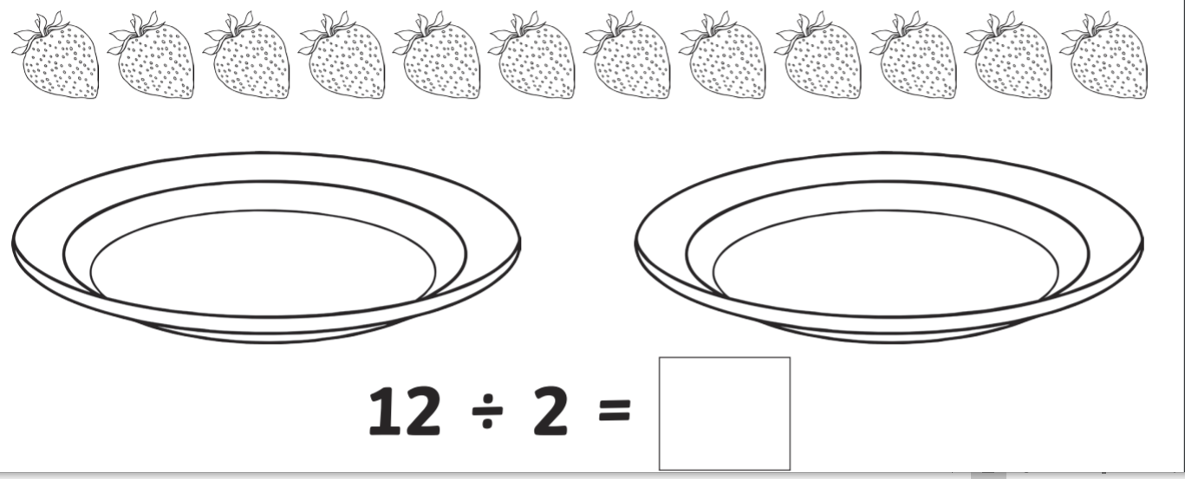  Half of 12 = 6  12 shared by 2 is 6  Make it  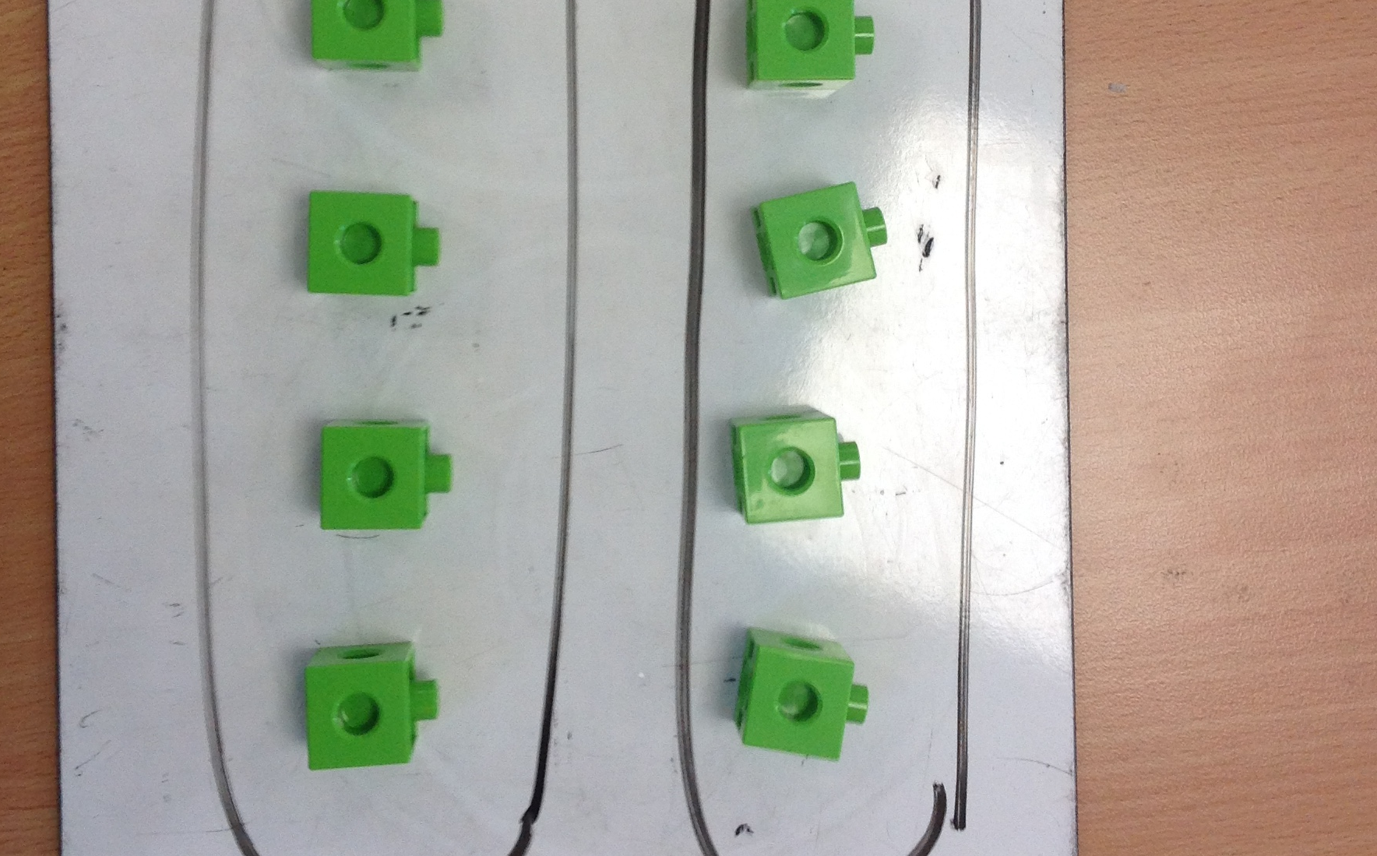  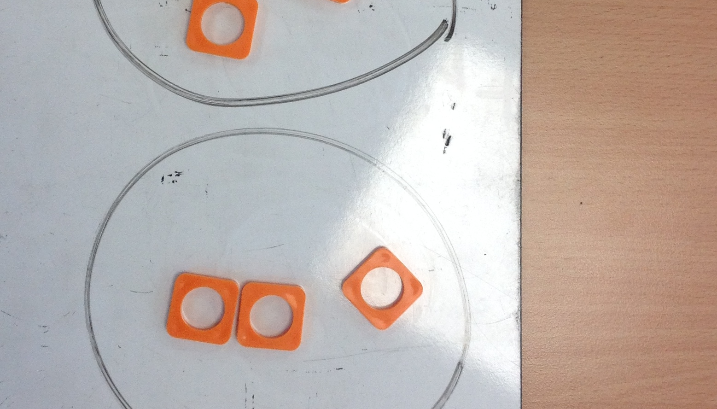  Draw it  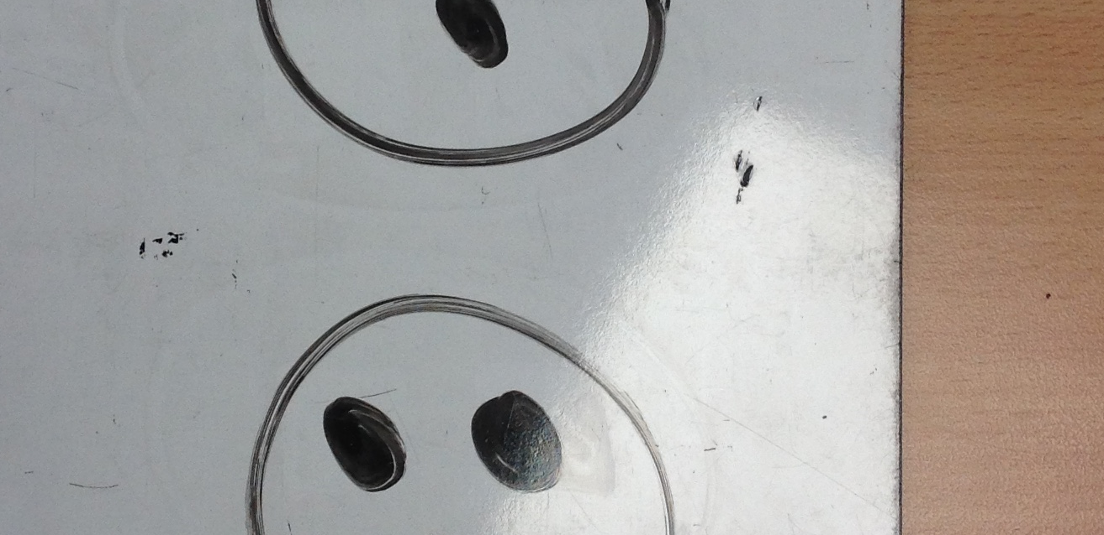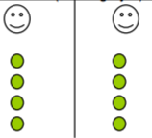  Write it  Half of 6 = 3  ½ 0f 6 = 3  6 ÷ 2 = 3
Year 2  TEACHER GUIDE  Use concrete apparatus initially and throughout to support understanding.  Using vocabulary ‘lots of’ for multiplication and ‘groups of’ for division when modelling process. You will count on in ‘lots of...’ or subtract in ‘groups of....’ |  | Make it - Using arrays to understand division  10 ÷ 2 = 5  Draw it - Repeated subtraction  35 ÷ 5= 7  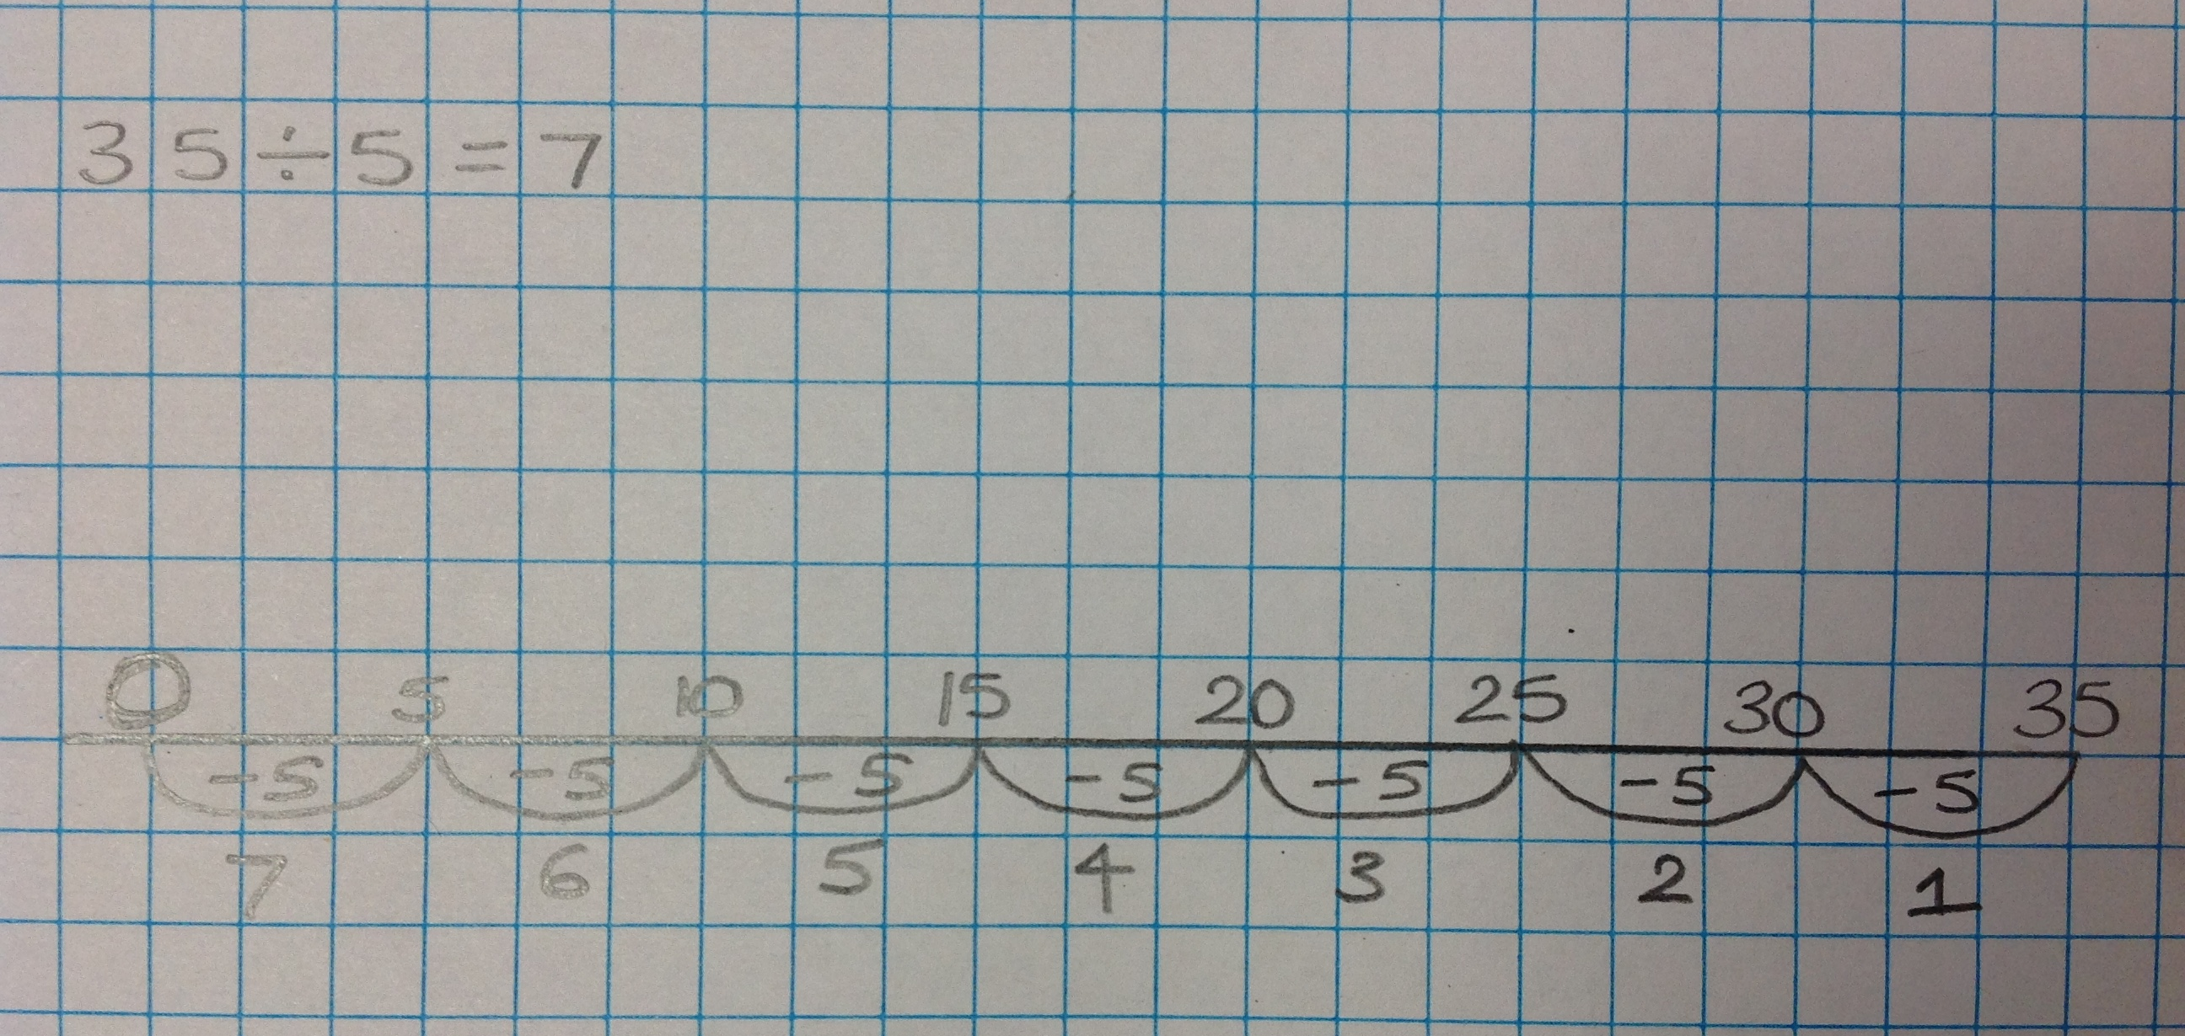  ALWAYS WRITE HOW MANY GROUPS ARE SUBTRACTED

