Objectives | ADDITION | SUBTRACTION
Year 3  Add and subtract numbers mentally, including:  - a three-digit number and ones  - a three-digit number and tens  - a three-digit number and hundreds  - add and subtract numbers with up to three digits, using formal written methods of columnar addition and subtraction | Make it  131 + 123 =  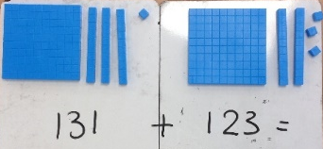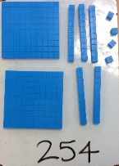  Draw it  134 + 32 = 166  163 + 122 =  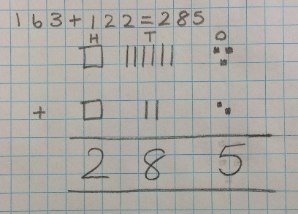  Write it - Compact written method  345 76  + 23 + 54  368 130  1  Extend to using with decimals  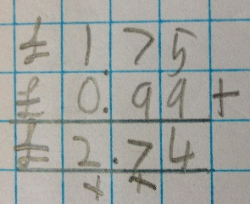 | Make it  74 – 33 =  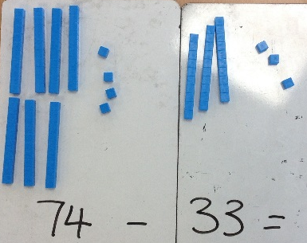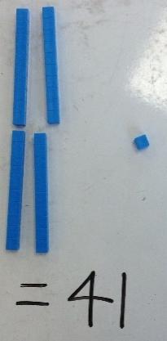  Draw it  145 – 22 =  163 – 41 =  

