Objectives | ADDITION | SUBTRACTION
Year 4  - add and subtract numbers with up to 4 digits using the formal written methods of columnar addition and subtraction where appropriate | Draw it  163 + 122 =  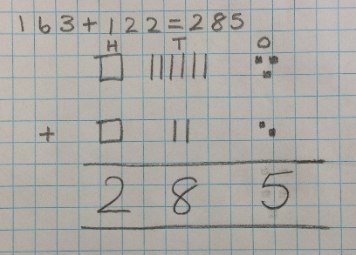  Write it – Column addition  1345 2376  +1223 + 1854  2568 4230  1 1 1  Extend to using with decimals  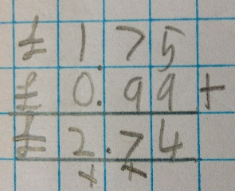 | Draw it  163 – 41 =  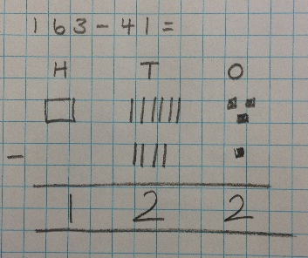  Write it – Column subtraction  6875  - 2342  4533  2  1  9  1  3076  - 381  2695  Extend to using with decimals  

