Objectives | ADDITION | SUBTRACTION
Year 5  - add and subtract whole numbers with more than 4 digits, including using formal written methods (columnar addition and subtraction) | Write it – Column addition  1345 2376  +1223 + 1854  2568 4230  1 1 1  Extend to using with larger numbers and decimals  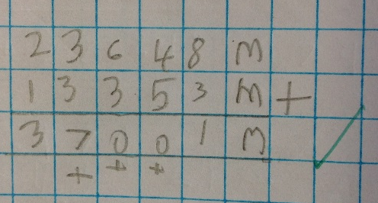  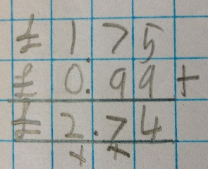 | Write it – Column subtraction  6875  - 2342  4533  2  1  9  1  3076  - 381  2695  Extend to using with decimals  

