Objectives | MULTIPLICATION | DIVISION
Year 3 | Recap on arrays and repeated addition from KS1  Make it/Write it - Grid method  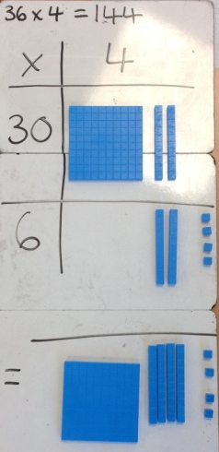  36 x 4 =  Write it - Grid method  45 x 6 =  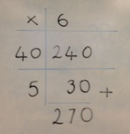 | Recap on sharing and repeated subtraction from KS1  Draw it - Repeated subtraction on a number line  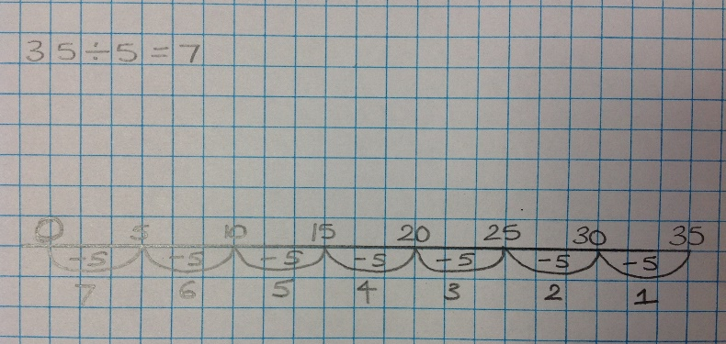  ALWAYS WRITE HOW MANY GROUPS ARE SUBTRACTED  Extend division on a number line to include remainders.  

