Objectives | MULTIPLICATION | DIVISION
Year 4  - multiply two-digit and three-digit numbers by a one-digit number using formal written layout | Write it - Grid method  45 x 6 =  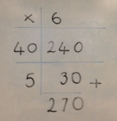 | Make it/Write it – Short Division with place value counters  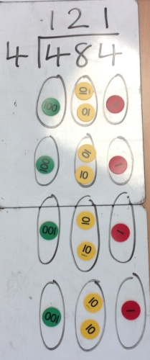  Write it – Short Division – generally introduced towards the end of Year 4  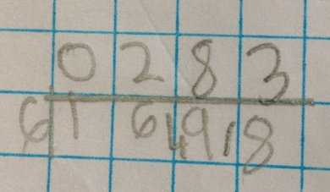  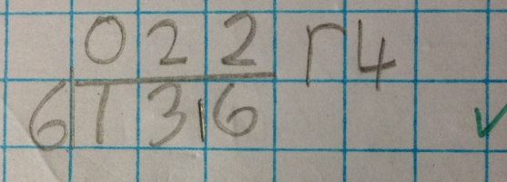
Write it - Compact methods

37
6 x
2 2 2
2 4

137
5 x
685
1 3

