Objectives | MULTIPLICATION | DIVISION
Year 5  - multiply numbers up to 4 digits by a one- or two-digit number using a formal written method, including long multiplication for two-digit numbers  - divide numbers up to 4 digits by a one-digit number using the formal written method of short division and interpret remainders appropriately for the context | Write it - Compact methods  37  6 x  2 2 2  2 4  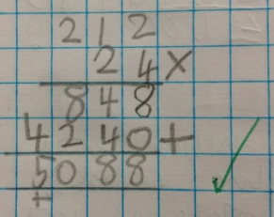  Extend to decimals  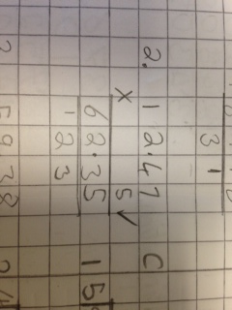 | Write it – Short Division  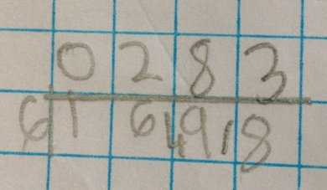  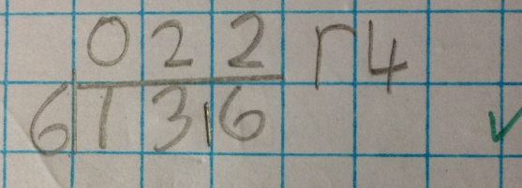  Extend to decimals  

