Objectives | MULTIPLICATION | DIVISION
Year 6  - multiply multi-digit numbers up to 4 digits by a two-digit whole number using the formal written method of long multiplication  - divide numbers up to 4 digits by a two-digit whole number using the formal written method of long division, and interpret remainders as whole number remainders, fractions, or by rounding, as appropriate for the context  - divide numbers up to 4 digits by a two-digit number using the formal written method of short division where appropriate, interpreting remainders according to the context | Write it - Compact methods  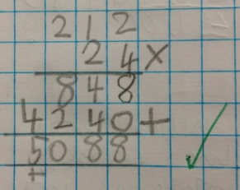  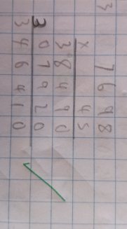  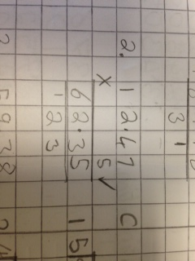  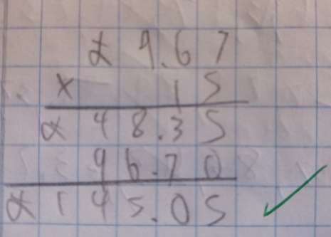 | Division of 2-digit numbers– Short Division  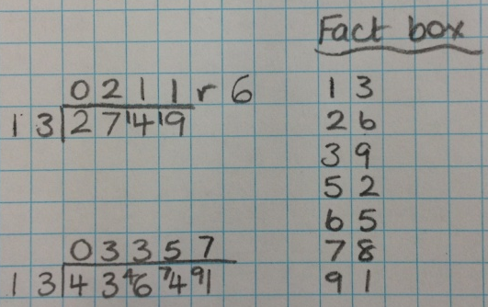  Division of 2-digit numbers–Long Division  

