Objectives
Year 5  - solve problems which require knowing percentage and decimal equivalents of ½,1/4,1/5,2/5,4/5 – (50%, 25%, 20%, 40%, 80%) | 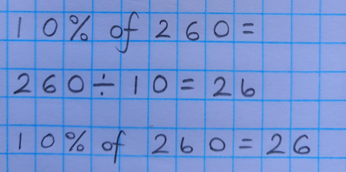  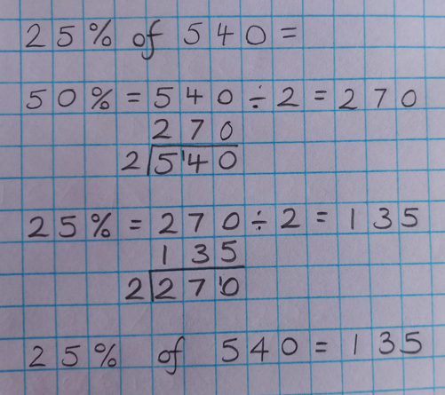  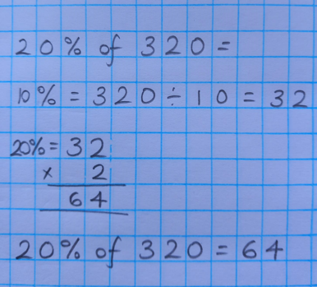  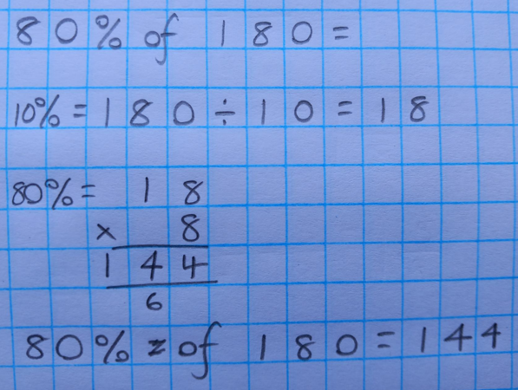
Year 6  - calculation of percentages [for example, of measures, and such as 15% of 360] | 

