Objectives | ADDITION | SUBTRACTION
Year 3 & 4  - add and subtract fractions with the same denominator | 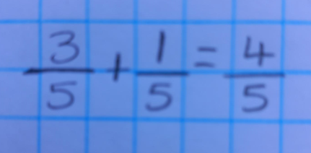 | 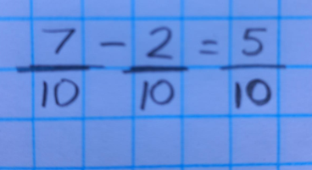
Year 5  - add and subtract fractions with the same denominator and denominators that are multiples of the same number | 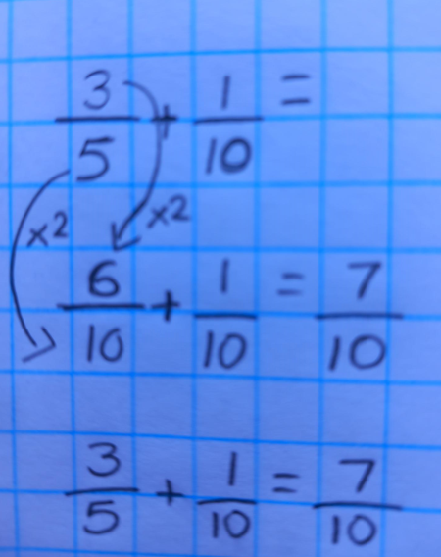 | 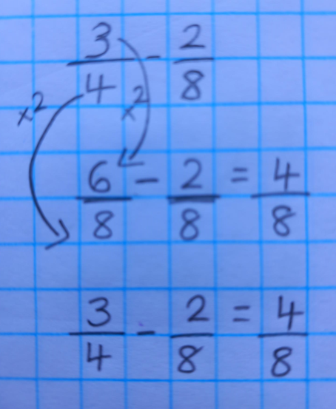
Year 6  - add and subtract fractions with mixed numbers and different denominators | 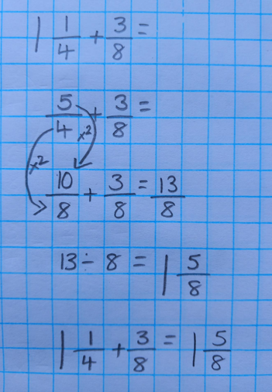 | 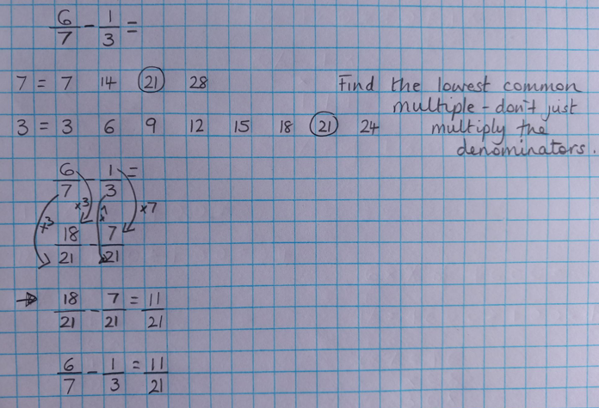

Objectives | MULTIPLICATION | DIVISION
Year 5  - multiply proper fractions and mixed numbers by whole numbers, | 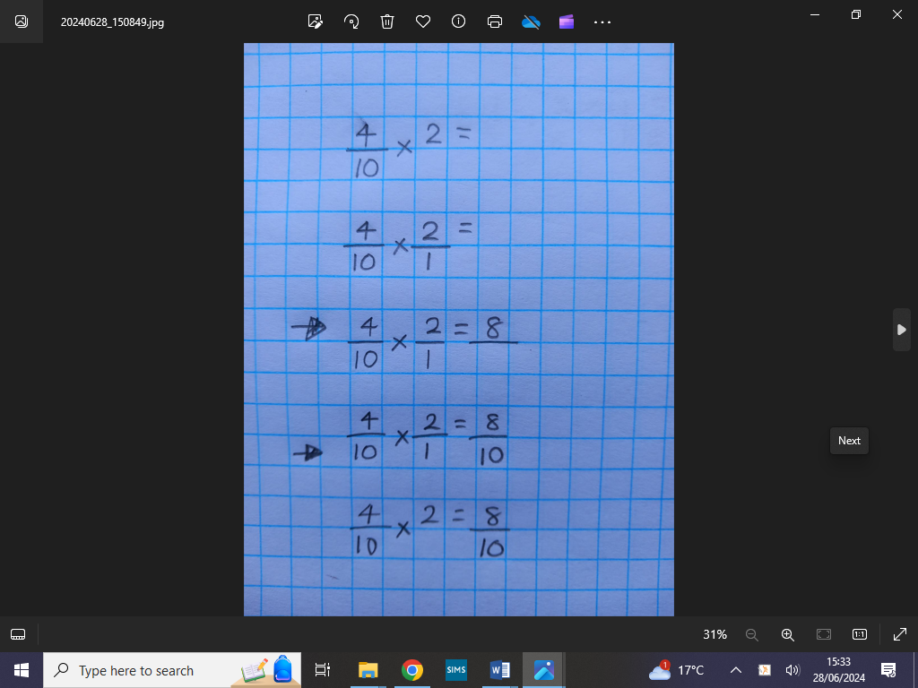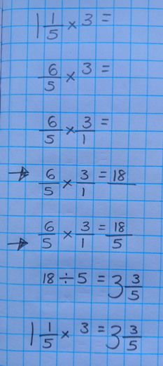
Year 6  - multiply simple pairs of proper fractions, writing the answer in its simplest form  - divide proper fractions by whole numbers | 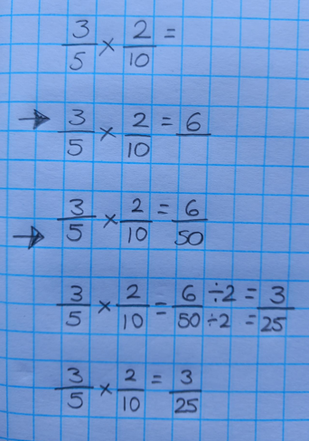 | 

