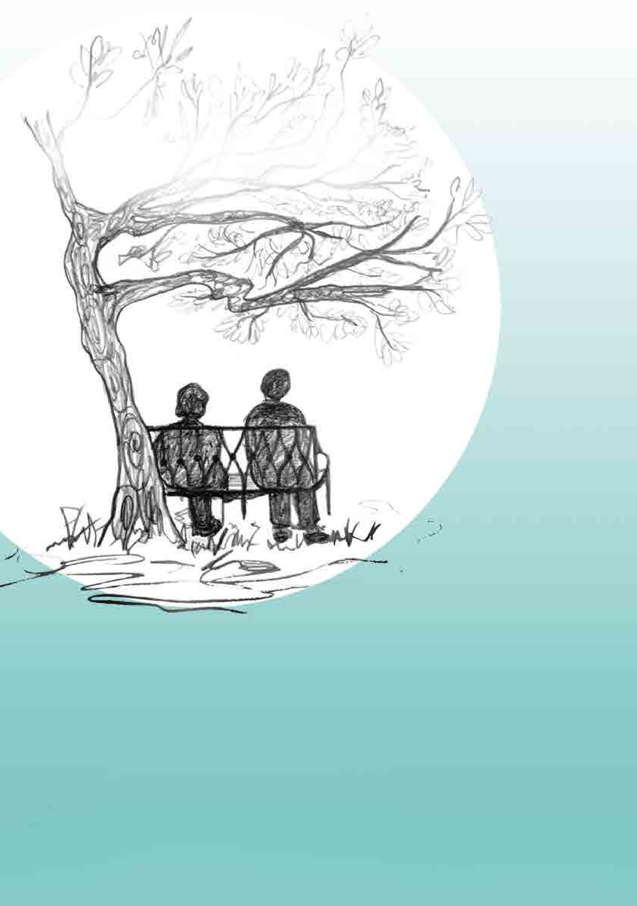
We are currently running a telephone only service.

This is
seven days a week from 4-10pm
.

You can call us on
01179 542 952
or
07709 295 661
.
After an initial informal assessment we will
allocate a time slot for people during
the evening when staff will call
back and offer support.
The Sanctuary
We hear you. We are here for you.
We are a safe place.
Service
update

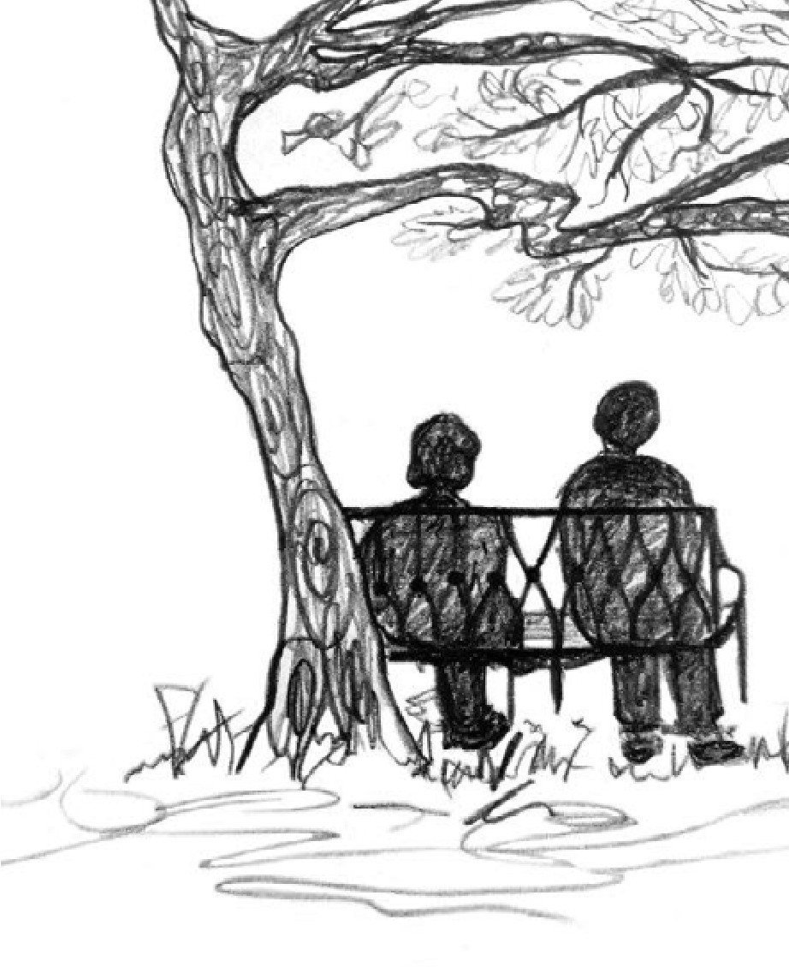

© 2017 St Mungo’s, Fifth Floor, 3 Thomas More Square, London E1W 1YW. Tel: 020 3856 6000 Fax: 020 3856 6001 www.mungos.org
St Mungo Community Housing Association is a registered charity and a limited company registered in England and Wales.
Registered Charity No 1149085, Company No 8225808, Housing Association No LH0279.
The Sanctuary is a safe space
for you, for when you can’t cope
any more or are feeling desperate
and alone.
We are running a telephone only
service, seven days a week from
4-10
pm. We will work with you as an
individual to try and find some balance.
Please call us to book a time and
help us to identify how
we can support you.
About us
The Sanctuary is managed by St Mungo’s.
St Mungo’s
is a charity and housing
association which manages emergency,
prevention and recovery services for
people who are homeless or at risk of
homelessness.
The Sanctuary is part of
Bristol Mental
Health
, created in 2014 following calls from
service users, carers and GPs for better
mental health services in the city.

