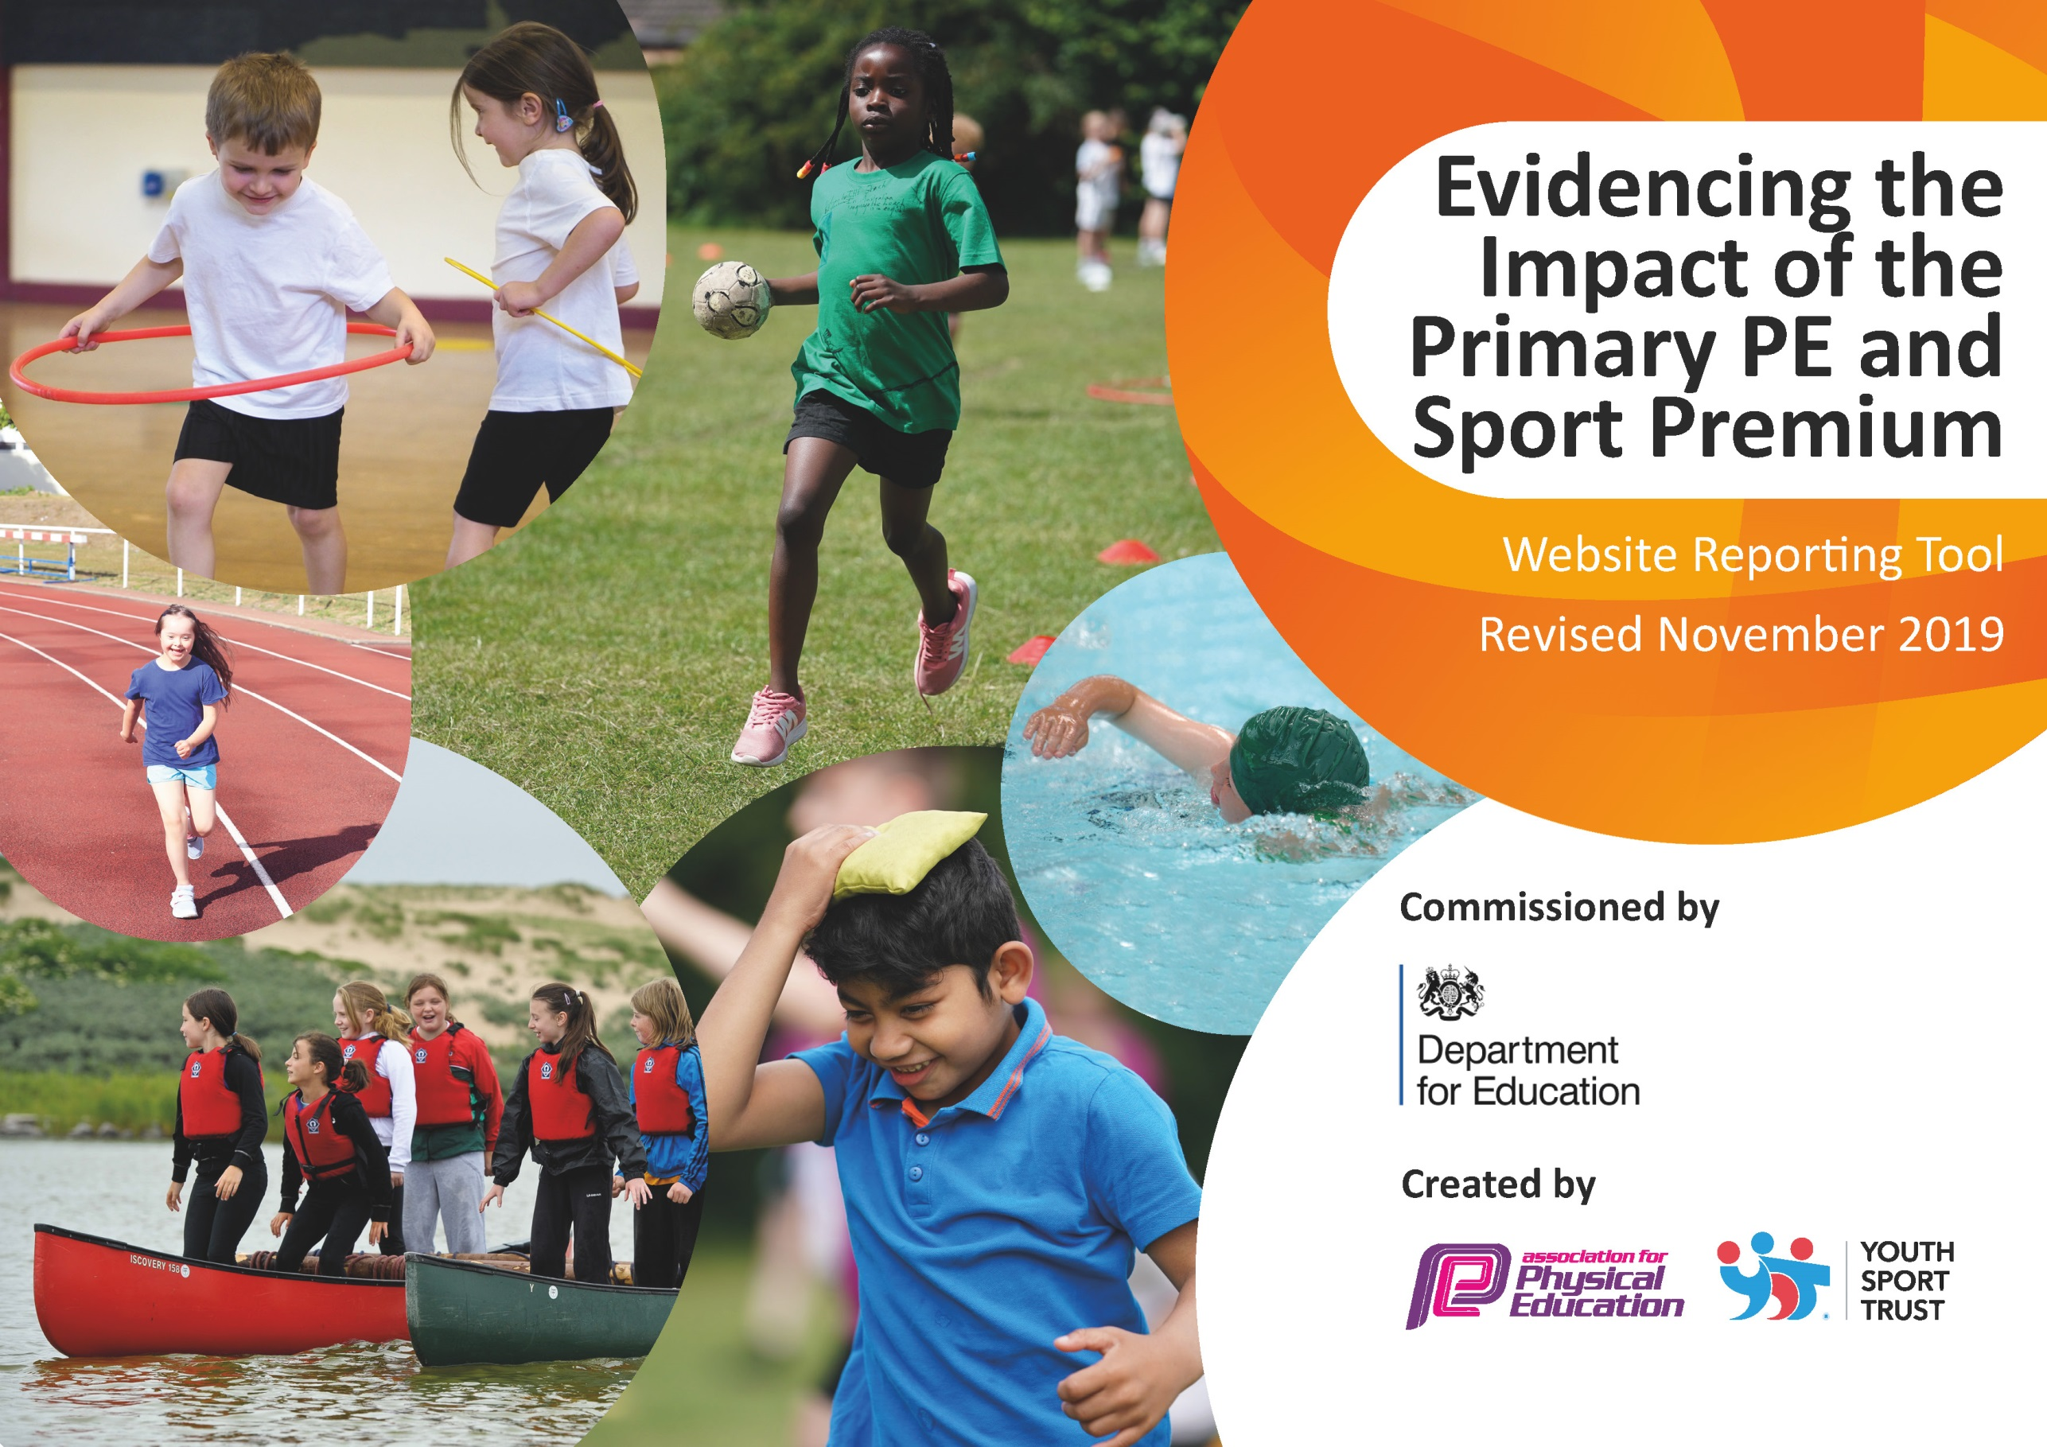
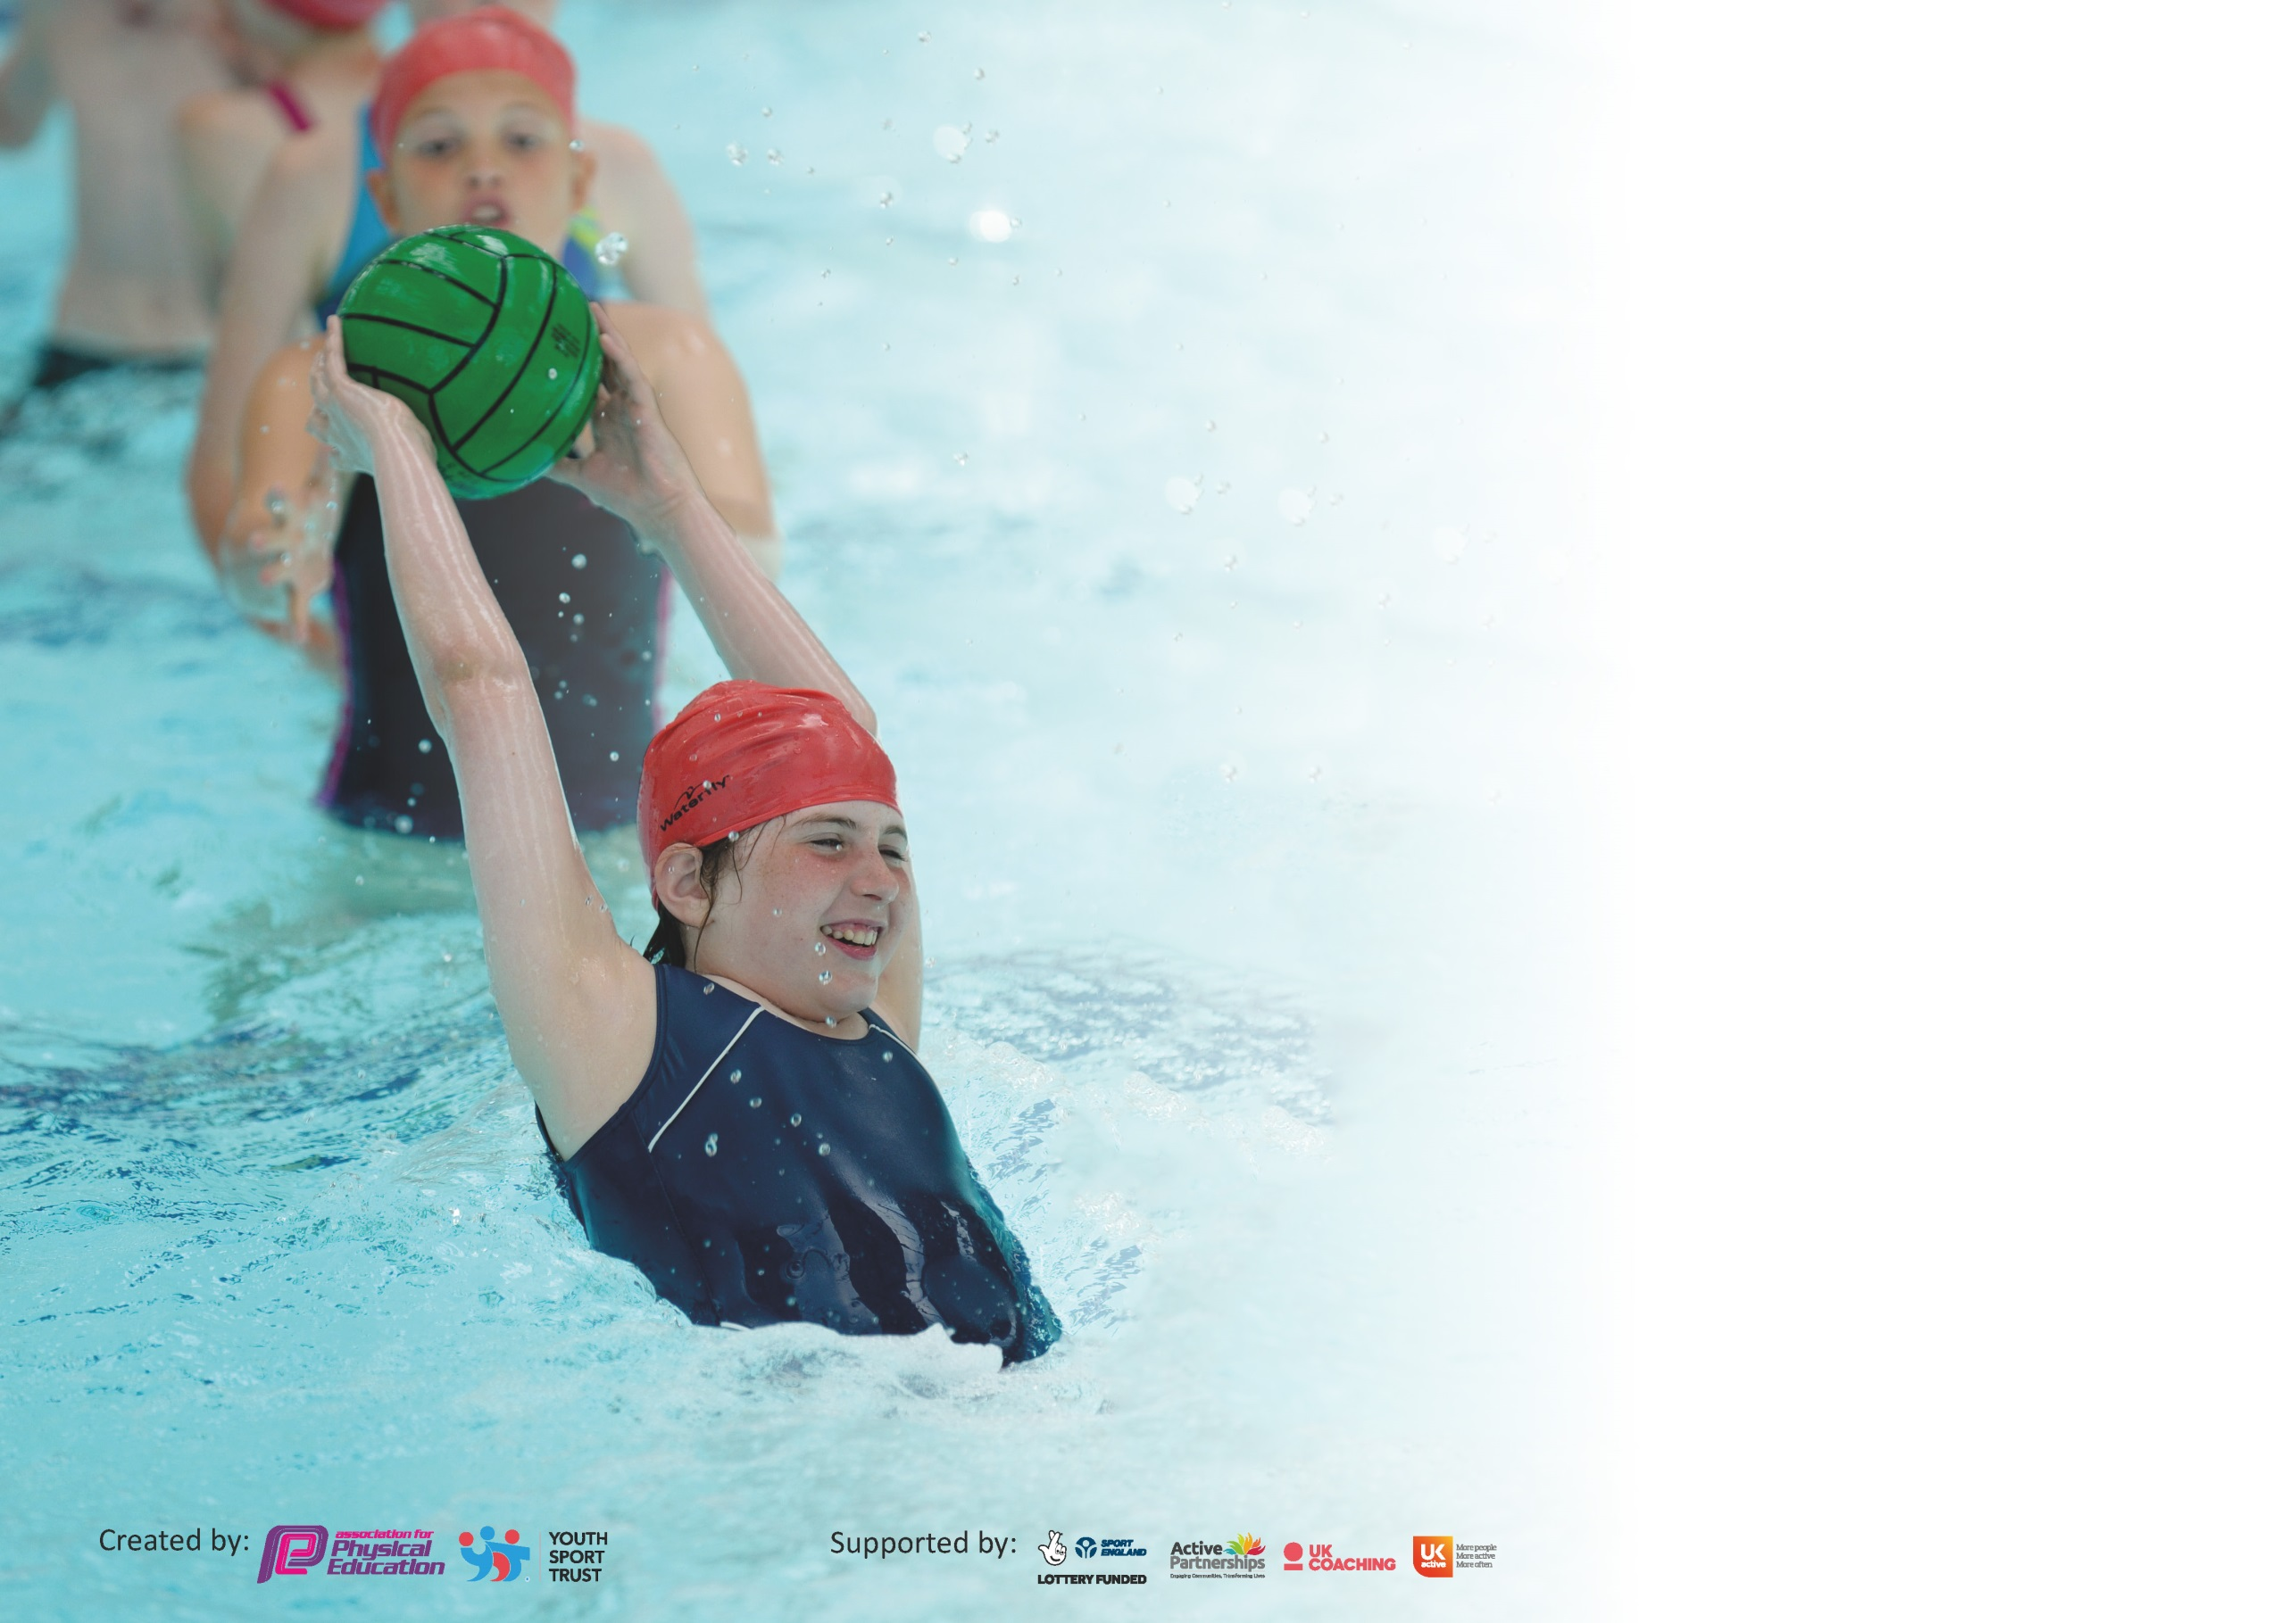

It is important that your grant is used effectively and based on school need. The Education Inspection Framework (Ofsted 2019 p64) makes clear there will be a focus on ‘whether leaders and those responsible for governors all understand their respective roles and perform these in a way that enhances the effectiveness of the school’.

Under the Quality of Education criteria (p41) inspectors consider the extent to which schools can articulate their curriculum (INTENT), construct their curriculum (IMPLEMENTATION) and demonstrate the outcomes which result (IMPACT).

To assist schools with common transferable language this template has been developed to utilise the same three headings which should make your plans easily transferable between working documents.

Schools must use the funding to make additional and sustainable improvements to the quality of Physical Education, School Sport and Physical Activity (PESSPA) they offer. This means that you should
use the Primary PE and Sport Premium to:

- Develop or add to the PESSPA activities that your school already offer
- Build capacity and capability within the school to ensure that improvements made now will benefit pupils joining the school in future years

Please visit gov.uk for the revised DfE guidance including the 5 key indicators across which schools should demonstrate an improvement. This document will help you to review your provision and to report your spend. DfE encourages schools to use this template as an effective way of meeting the reporting requirements of the Primary PE and Sport Premium.

We recommend you start by reflecting on the impact of current provision and reviewing the previous spend.

Schools are required to publish details of how they spend this funding as well as on the impact it has on pupils’ PE and sport participation and attainment by the end of the summer term or by 31st July 2020 at the latest.

We recommend regularly updating the table and publishing it on your website throughout the year. This evidences your ongoing self-evaluation of how you are using the funding to secure maximum, sustainable impact. Final copy must be posted on your website by the end of the academic year and no later than the 31st July 2020. To see an example of how to complete the table please click HERE.

Support for review and reflection - considering the 5 key indicators from DfE, what development needs are a priority for your setting and your pupils now and why? Use the space below to reflect on previous spend and key achievements and areas for development.

Key achievements to date until July 2019: | Areas for further improvement and baseline evidence of need:
- Achieving silver kite mark  - Running a variety of out of school clubs  - Competing in new sporting inter-competitions such as archery  - Competing in a range of inter and intra competitions  - Developing a progression of skills assessment document for swimming and gymnastics | - Monitoring class assessment and teachers lesson plans  - Ensuring that teachers are consistently monitoring their children activities. Who are the in-active children? How are we going to engage those children?  - Register keeping for clubs

Meeting national curriculum requirements for swimming and water safety.
What percentage of your current Year 6 cohort swim competently, confidently and proficiently over a distance of at least 25 metres?  N.B. Even though your pupils may swim in another year please report on their attainment on leaving  primary school at the end of the summer term 2020. | 36%
What percentage of your current Year 6 cohort use a range of strokes effectively [for example, front crawl, backstroke and breaststroke]? | 40%
What percentage of your current Year 6 cohort perform safe self-rescue in different water-based situations? | 75%
Schools can choose to use the Primary PE and Sport Premium to provide additional provision for swimming but this must be for activity over and above the national curriculum requirements. Have you used it in this way? | Yes/No

Action Plan and Budget Tracking
Capture your intended annual spend against the 5 key indicators. Clarify the success criteria and evidence of impact that you intend to measure to evaluate for pupils today and for the future.

Academic Year: 2019/20 | Total fund allocated: £20919 | Date Updated: July 2020
Key indicator 1: The engagement of all pupils in regular physical activity – Chief Medical Officer guidelines recommend that primary school pupils undertake at least 30 minutes of physical activity a day in school |  |  |  | Percentage of total allocation:
 |  |  |  | %
Intent | Implementation |  | Impact
Your school focus should be clear what you want the pupils to know and be able to do and about  what they need to learn and to  consolidate through practice: | Make sure your actions to achieve are linked to your intentions: | Funding allocated: | Evidence of impact: what do pupils now know and what can they now do? What has changed?: | Sustainability and suggested next steps:
Encourage participation in school competitions- athletics, inclusive sports, team sports  Increase participation in extra curricular clubs  Promote active breaks during the learning time of the school day | Engage with CSET sports partnership, increase opps for children to attend  Actively target specific groups of children and pay for places for PP /vulnerable pupils  Staff training on possible active breaks that are easier to manage  Recording sheets provided to log the active time in lessons | £3250  £2145 | Lockdown challenges were shared and Barley Close had some take up  Less clubs operating due to COVID  Active breaks seen in lessons across the school- more children active in the school day | Continue with partnership and continue to take up offers by CSET  Continue to offer arrange of extra curricular activities  Continue active break/active opportunities in lessons
Key indicator 2: The profile of PESSPA being raised across the school as a tool for whole school improvement |  |  |  | Percentage of total allocation:
 |  |  |  | %
Intent | Implementation |  | Impact
Your school focus should be clear what you want the pupils to know and be able to do and about  what they need to learn and to  consolidate through practice: | Make sure your actions to achieve are linked to your intentions: | Funding allocated: | Evidence of impact: what do pupils now know and what can they now do? What has changed?: | Sustainability and suggested next steps:
Use PE and school sport as a tool to close the gap of vulnerable pupils and provide them with strategies to access learning and to improve behaviour  Improve mental health of pupils and to allow them opportunities to talk about their emotions and how to manage them | Use PE coach from progressive sports to run mentoring sessions with selected children focused on self esteem, team work and moderating of behaviour within curriculum time  Use PE coach from progressive sports to run active wellbeing workshops across the school- a term per year grp | £8704  £5460 | Reduced FEX across schools. this has been done online in lockdown so varying degrees of uptake by some pupils  Pupils talk positively about the sessions and how it helps them with life although mainly done online so impact has been varied | Continue to target key children through mentoring programme  Continue programme of wellbeing support

Key indicator 3: Increased confidence, knowledge and skills of all staff in teaching PE and sport |  |  |  | Percentage of total allocation:
 |  |  |  | %
Intent | Implementation |  | Impact
Your school focus should be clear | Make sure your actions to | Funding | Evidence of impact: what do | Sustainability and suggested
what you want the pupils to know | achieve are linked to your | allocated: | pupils now know and what | next steps:
and be able to do and about | intentions: |  | can they now do? What has
what they need to learn and to |  |  | changed?:
consolidate through practice:
Increase staff confidence in delivery of specific PE sessions as identified on staff audit | Team teaching with progressive sports PE coaches | £4610 | Staff audits say they are being to feel more confident in delivery although has been inconsistent and not with whole classes due to lockdowns
Key indicator 4: Broader experience of a range of sports and activities offered to all pupils |  |  |  | Percentage of total allocation:
 |  |  |  | %
Intent | Implementation |  | Impact
Your school focus should be clear | Make sure your actions to | Funding | Evidence of impact: what do | Sustainability and suggested
what you want the pupils to know | achieve are linked to your | allocated: | pupils now know and what | next steps:
and be able to do and about | intentions: |  | can they now do? What has
what they need to learn and to |  |  | changed?:
consolidate through practice:
Additional achievements:  Introduce new sports as part of curriculum and enrichment activities | Friday lunchtime club, multi sports club not focusing on football | Share of £2145 | Due to COVID restrictions this has not happened | Continue to offer a variety of clubs

Key indicator 5: Increased participation in competitive sport |  |  |  | Percentage of total allocation:
 |  |  |  | %
Intent | Implementation |  | Impact
Your school focus should be clear | Make sure your actions to | Funding | Evidence of impact: what do | Sustainability and suggested
what you want the pupils to know | achieve are linked to your | allocated: | pupils now know and what | next steps:
and be able to do and about | intentions: |  | can they now do? What has
what they need to learn and to |  |  | changed?:
consolidate through practice:
Provide opportunities for children to represent the school in a variety of sports | Advertise and take children to competitions- swimming gala, dance festival, cross country, sportshall |  | None due to COVID many events stopped | Continue when possible again

Signed off by
Head Teacher: | Jo williams
Date: | July 2020
Subject Leader: | Sam Haywood-Pope
Date: | July 2020
Governor: | Lucy Brazier
Date: | July 2020

