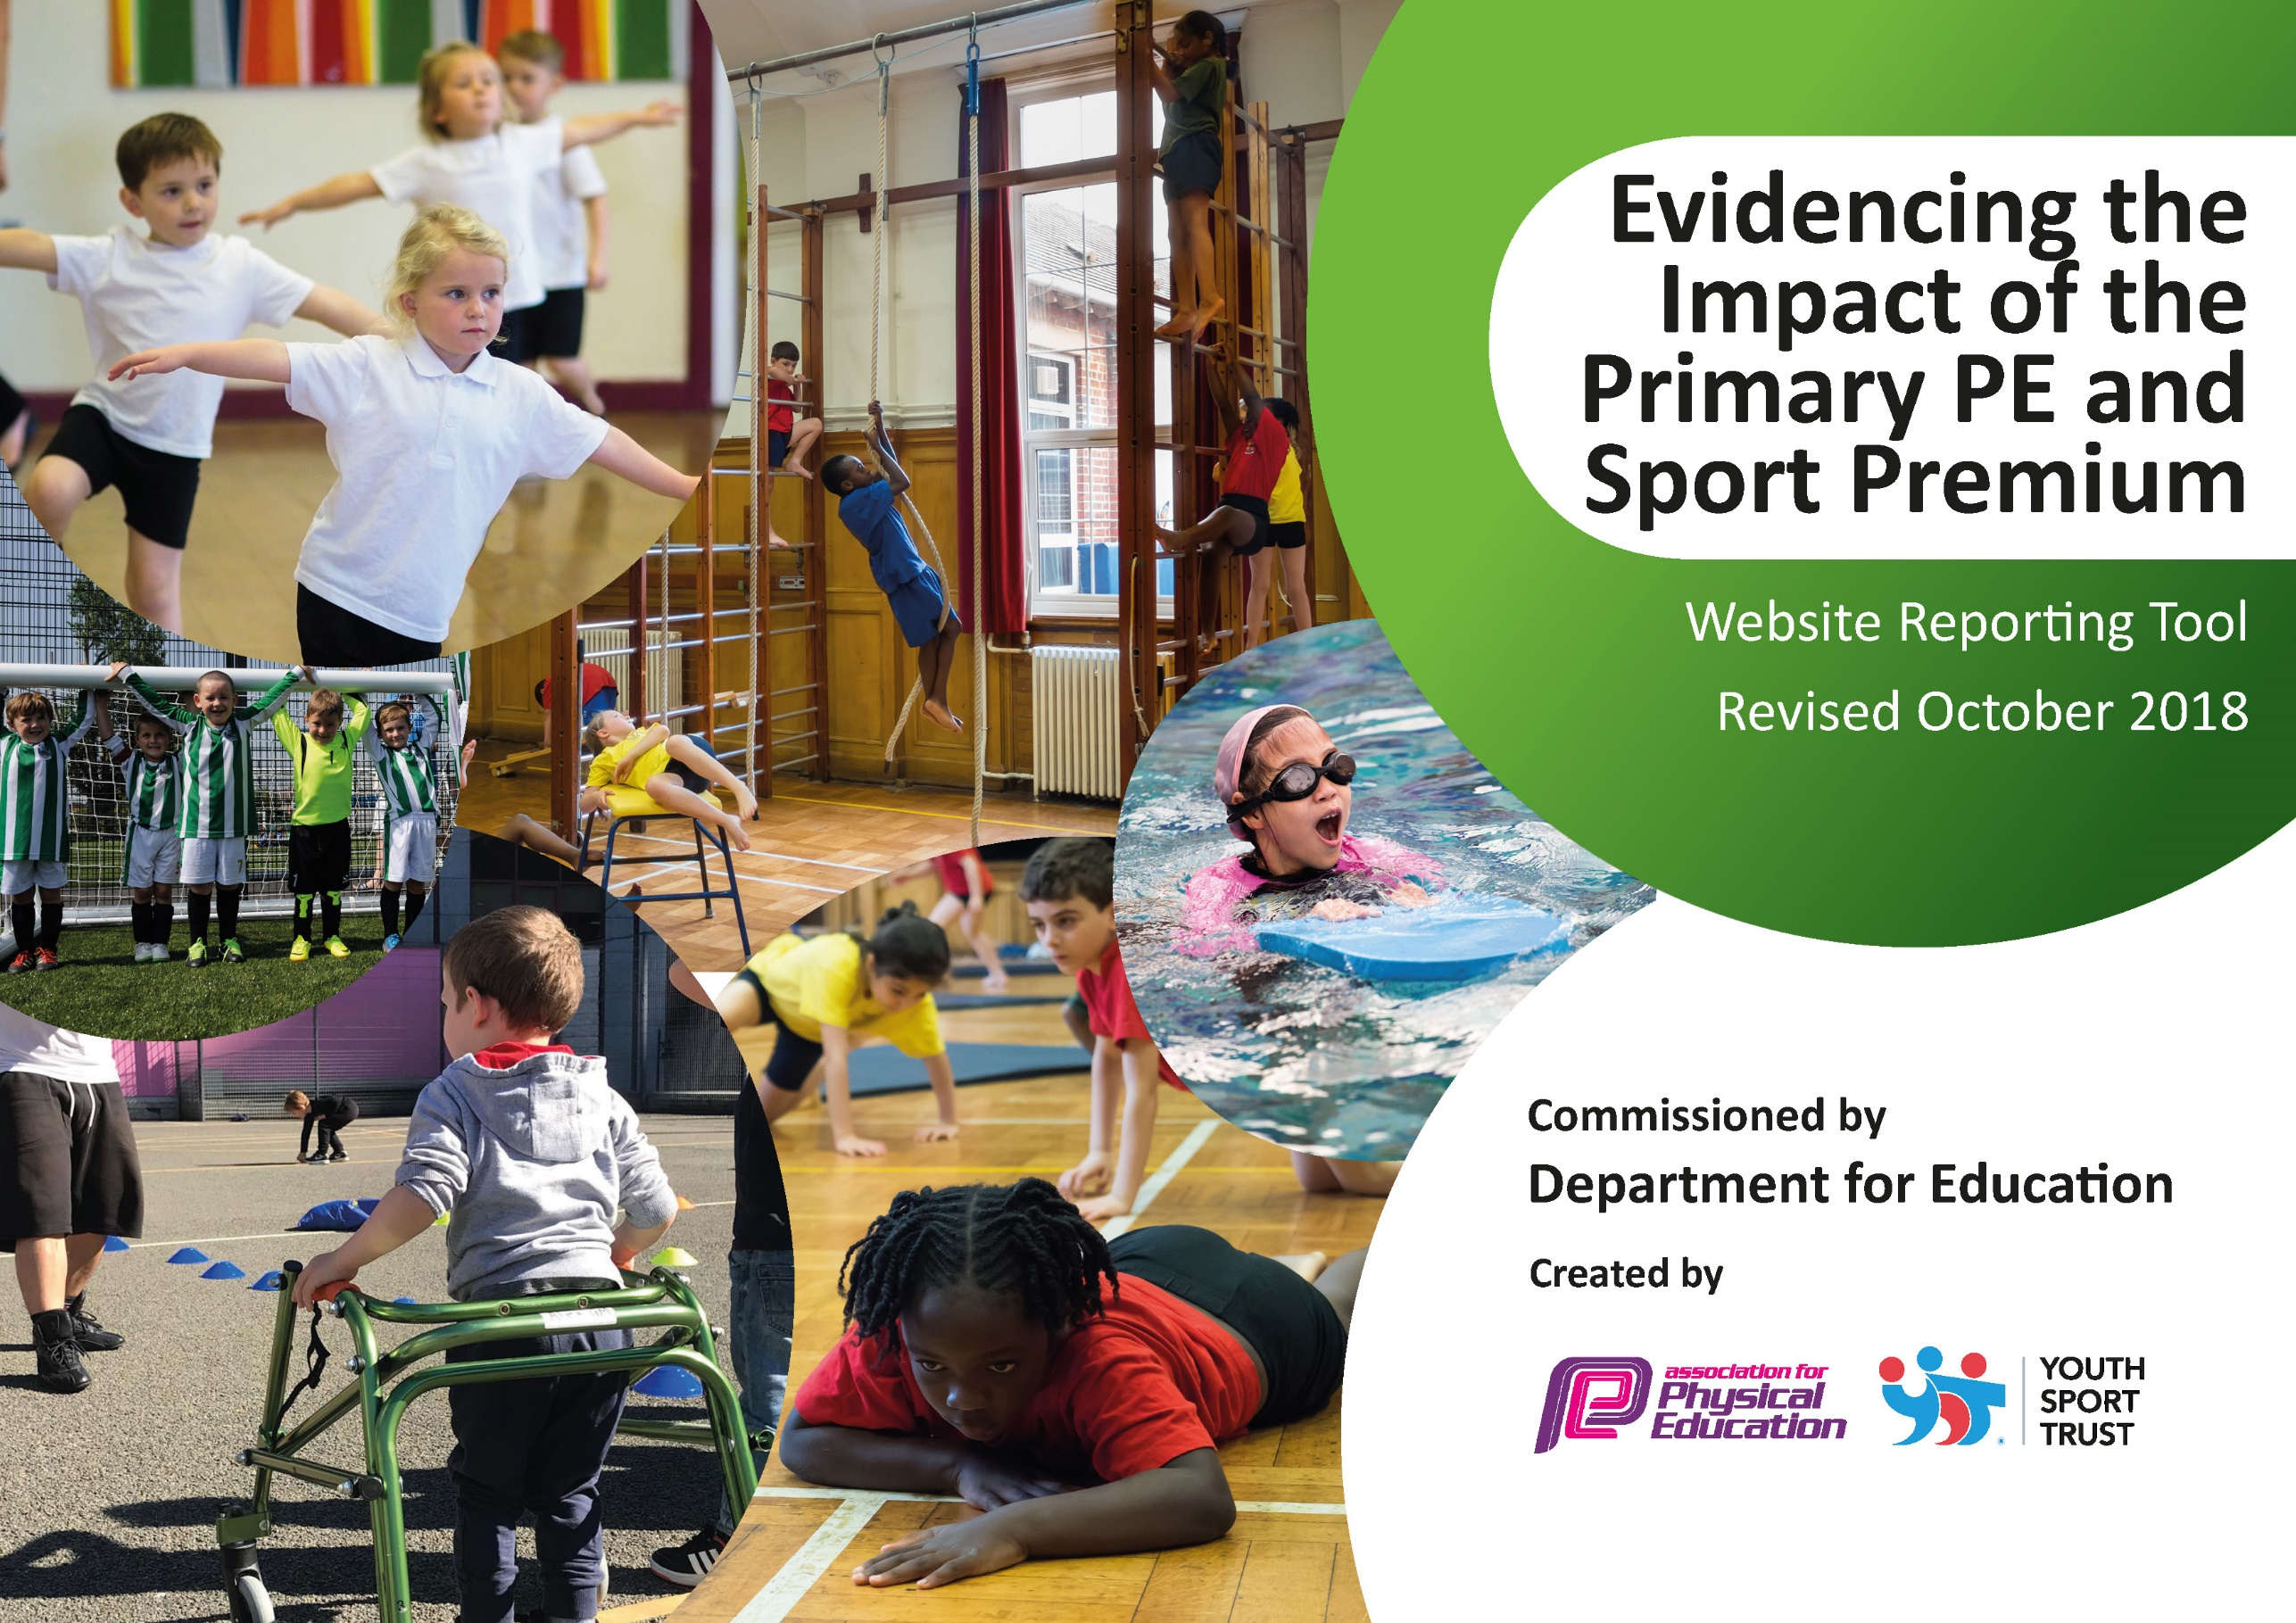
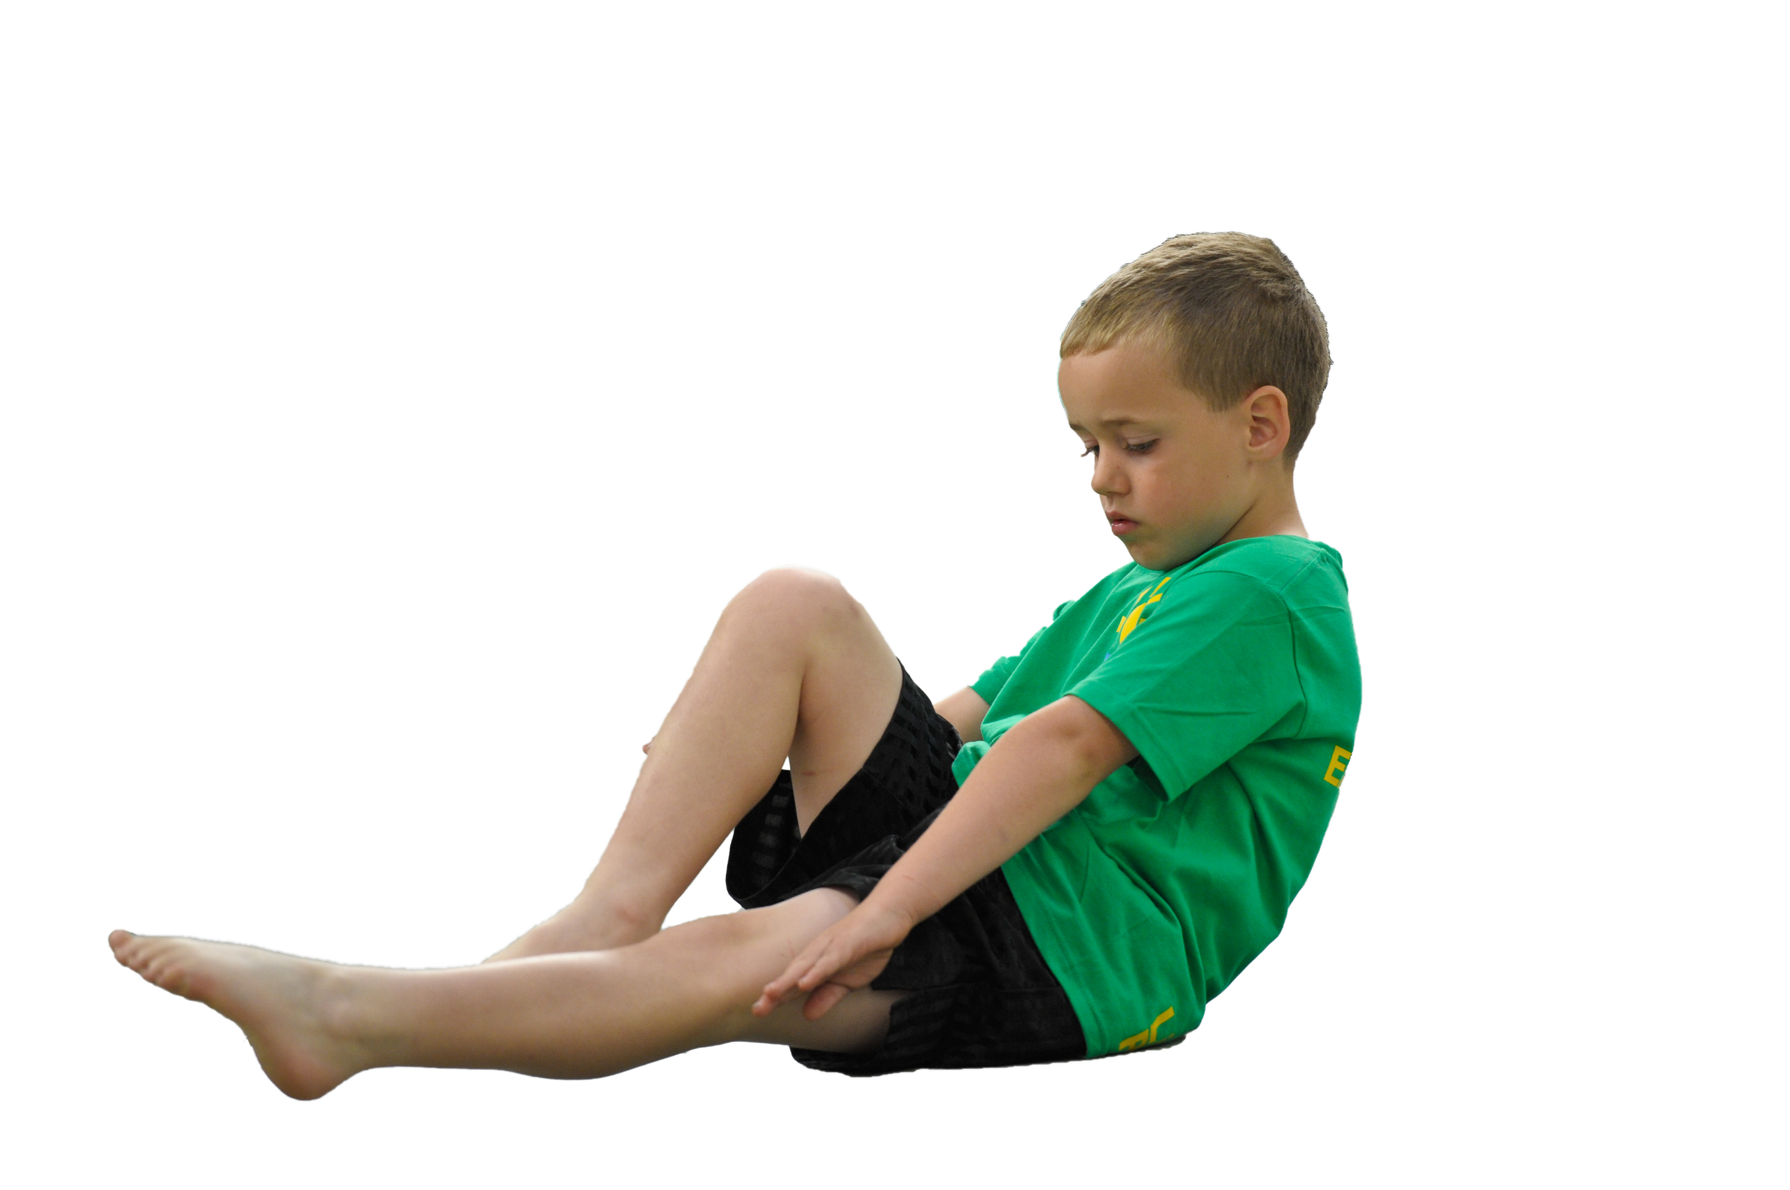
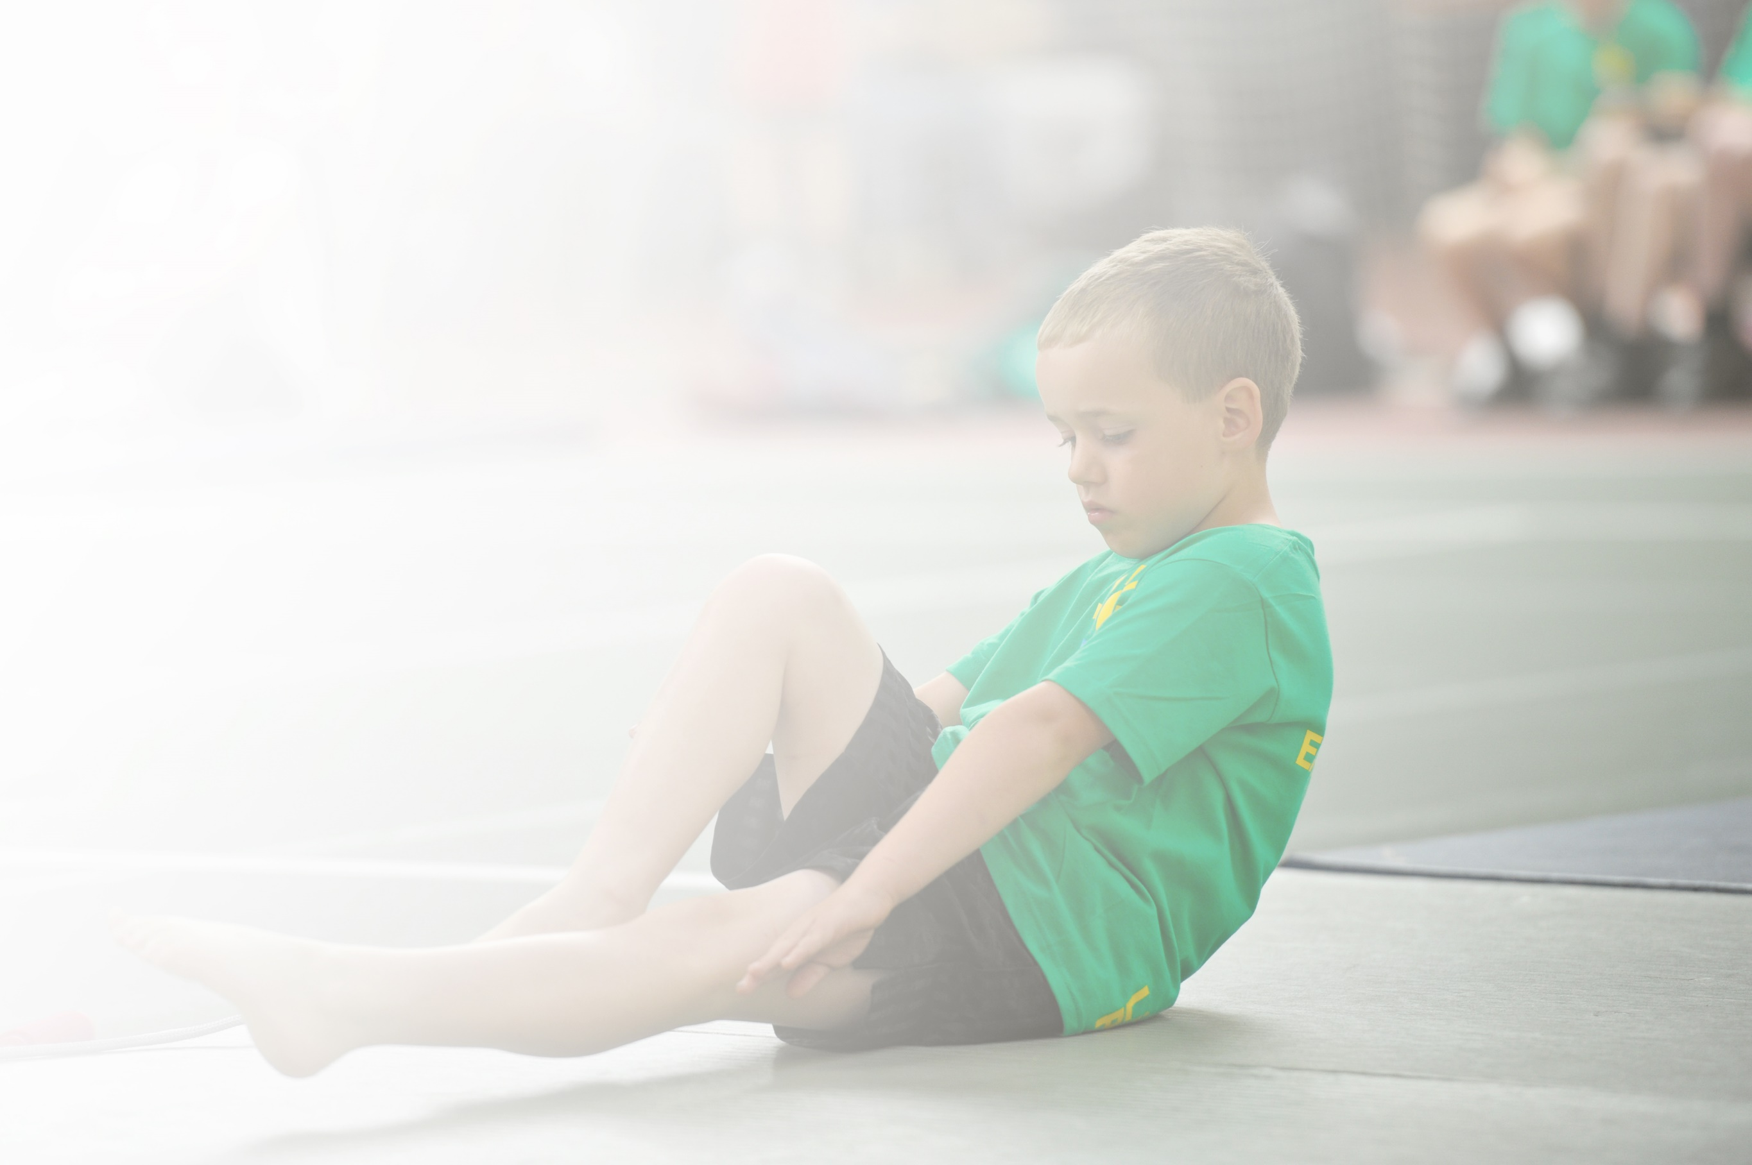
Schools must use the funding to make additional and sustainable improvements to the quality of Physical Education, Sport and Physical Activity (PESPA) they offer. This means that you should use the Primary PE and Sport Premium to:

- Develop or add to the PESPA activities that your school already offer
- Build capacity and capability within the school to ensure that improvements made now will benefit pupils joining the school in future years

Please visit gov.uk for the revised DfE guidance including the 5 key indicators across which schools should demonstrate an improvement. This document will help you to review your provision and to report
your spend. DfE encourages schools to use this template as an effective way of meeting the reporting requirements of the Primary PE and Sport Premium.

We recommend you start by reflecting on the impact of current provision and reviewing the previous
spend. Under the Ofsted Schools Inspection Framework, inspectors will assess how effectively leaders use the Primary PE and Sport Premium and measure its impact on outcomes for pupils, and how effectively governors hold them to account for this.

Schools are required to publish details of how they spend this funding as well as on the impact it has on pupils’ PE and sport participation and attainment by the end of the summer term or by 31 July 2019 at the
latest.
We recommend regularly updating the table and publishing it
on your website throughout the year, as evidence of your
ongoing review into how you are using the money to
secure maximum, sustainable impact. To see an
example of how to complete the table please
click HERE.

Support for review and reflection - considering the 5 key indicators from DfE, what development needs are a priority for your setting and your students now and why? Use the space below to reflect on previous spend, identify current need and priorities for the future.

Key achievements to date: | Areas for further improvement and baseline evidence of need:
- Raised competition participation in KS1  - Funding secure for swimming facilities to be refurbished  - Lifesavers trained for swimming | - To promote activities for all by promoting personal challenge, intra competitions and continuing C4L club.

Meeting national curriculum requirements for swimming and water safety | Please complete all of the below:
What percentage of your current Year 6 cohort swim competently, confidently and proficiently over a distance of at least 25 metres?  N.B. Even though your children may swim in another year please report on their attainment on leaving  primary school. | 45%
What percentage of your current Year 6 cohort use a range of strokes effectively [for example, front crawl, backstroke and breaststroke]? | 51%
What percentage of your current Year 6 cohort perform safe self-rescue in different water-based situations? | 75%
Schools can choose to use the Primary PE and Sport Premium to provide additional provision for swimming but this must be for activity over and above the national curriculum requirements. Have you used it in this way? | Yes/No

Action Plan and Budget Tracking
Capture your intended annual spend against the 5 key indicators. Clarify the success criteria and evidence of impact that you intend to measure to evaluate for students today and for the future.

Academic Year: 2018/19 | Total fund allocated: £19134.00 | Date Updated: 13/07/19
Key indicator 1: The engagement of all pupils in regular physical activity – Chief Medical Officer guidelines recommend that primary school children undertake at least 30 minutes of physical activity a day in school |  |  |  | Percentage of total allocation:
 |  |  |  | %
School focus with clarity on intended impact on pupils: | Actions to achieve: | Funding allocated: | Evidence and impact: | Sustainability and suggested next steps:
To continue to provide a range of sports clubs during school and out of school hours.  Active 30 – developing 30 minutes of physical activity everyday | - To see an increase of children taking part in extra-curricular sports. Ensuring that we have evidence of this through register keeping. Comparing numbers to previous terms.  - To achieve maximum participation by running intra competitions in line with sports club offer.  - To continue links with outside clubs:  Martial Arts  Carsons  Mangotsfield Cricket Club  Swimming Clubs  Girls football  - Active lunchtimes:  scrap store  Forest Schools lessons  - Playground games - Leaders training by the CSET sports partnership to run lunchtime activities.  - Gardening Club with Alison King (SEND)  - Activall  - Breakfast Club  - Travel Tracker (encourage walking to school at least 3 times a week to receive a badge at the end of the term.  - Healthy eating (new classroom resources) – change for life? | Girls football - £480  CSET - £3125  Activall - £1250 | Out of school hours timetables.  Class registers  Sports week year group competitions  Outside clubs hiring the school hall and swimming pool  Student voice/ photos  Cross curricular – maths outside in the forest schools area.  List of attendees  Photos  Children have access to the activall during breakfast club sessions.  Assemblies, a visit from the Travel Tracker mascot.  New freestanding signs set up on the road outside the school to encourage parents to park elsewhere when dropping their children off at school.  Cross-curricular activities – weighing and measuring.  Photos  Increase the profile of healthy eating. | To have at least one sports club offered each night afterschool.  Termly intra competitions between year groups and key stages.  Continue to let out the hall and swimming pool to other companies.  Buy in sports coaches to continue sports provision.  Year 5 + 6 leaders trained for next year. New year 5s will be trained up in September to boost leaders numbers. New year 5 trained and supported the running of sports day.  New planters installed to increase the range of fruits and vegetables that can be planted during the academic year.  Activall to be continue to be available each morning to encourage physical activity and personal best challenges.  To continue to monitor and reward children who walk to school with the travel tracker badges.  Potentially the return of the change for life club.
Key indicator 2: The profile of PESSPA being raised across the school as a tool for whole school improvement |  |  |  | Percentage of total allocation:
 |  |  |  | %
School focus with clarity on intended impact on pupils: | Actions to achieve: | Funding allocated: | Evidence and impact: | Sustainability and suggested next steps:
Visits from sporting stars – Lee Haskins and Sam Matthews  Sports leaders trained to run activities  All children experience intra-competition and strive to improve their personal best in activities e.g. the Activall  Clubs  Publishing match/event results and reports | To inspire inactive children and to further engage already activity children.  Sports leaders used to help set up and judge during sports day.  Class competitions taking places on a regularly basis.  Cross curricular links with maths, science.  To provide a wide range of sport clubs for children afterschool and during lunchtimes  The regularly publishing/ reporting of match/event reports and results to celebrate success and encourage other children to participate. | Voluntary | Pictures, assembly, website, feedback from children – Elena’s class.  Pictures, list of attendees  Pictures, records, website, assembly  Club registers, pictures, timetable, assembly  Newsletter, school website, assemblies | To continue to make links with local sports clubs and teams. Provide a wider range of sporting stars to include those with additional needs.  Continue to use sports leaders to run activities during lunchtimes and termly sporting events/ intra competitions.  To provide more opportunities for children to compete in intra-competitions and to continue to beat their personal best in a variety of different sports.  To provide more opportunities during school time for children to participate in sporting clubs. Progressive sports to be use to provide clubs at lunchtimes weekly, as well as afterschool.  The school website will continue to publish intra/inter competition results. We will develop more opportunities to share photographs and video clips on the school website and school social media as well.

Key indicator 3: Increased confidence, knowledge and skills of all staff in teaching PE and sport |  |  |  | Percentage of total allocation:
 |  |  |  | %
School focus with clarity on intended  impact on pupils: | Actions to achieve: | Funding  allocated: | Evidence and impact: | Sustainability and suggested  next steps:
To improve and sustain the teaching of PE across the school.  To develop skills and knowledge of all staff.  PE Co-ordinator observes PE lessons  Lifesaver training | Attend CPD courses provided by CSET – see calendar  Employment of Progressive Sports (6 weeks per year with each class in KS2) with class teacher observing  Quality support  Support staff trained to be lifesavers during swimming lessons. | See indicator 1  £5,320 – Progressive Sports | Registers  Staff who have been on CPD opportunities with CSET now feel more confident to deliver PE lessons.  Teachers feel more confident in delivering team games, setting up intra competitions etc.  PE co-ordinators have monitored and observed PE planning and lessons and have developed assessment procedures to help support the whole staff in their teaching.  Register of attendees, certificates of completion of course | We will use subject knowledge audits to identify which teachers need targeted CPD opportunities and work with CSET partnership to communicate our needs.  To continue next year.  Continue to observe PE lessons on a regular basis and gather resources to help in the planning and implementation of the lessons.  Lifesavers will attend refresher training when their certificates run out.
Key indicator 4: Broader experience of a range of sports and activities offered to all pupils |  |  |  | Percentage of total allocation:
 |  |  |  | %
School focus with clarity on intended  impact on pupils: | Actions to achieve: | Funding  allocated: | Evidence and impact: | Sustainability and suggested  next steps:
Additional achievements:  Visits from sporting stars – Lee Haskins and Sam Matthews  After school clubs  Lunch clubs  Breakfast club  CSET Competition calendar  PE association events  Up-keep of the swimming pool  First Strokes swimming club based at school pool  Swimming offered to all year groups – attainment | Reception classes are taught swimming by a trained swimming coach from First Strokes | See indicator 1 and 3  First Strokes - £780 |  | We will continue to be dedicated to offering a wide range of different sports for the children in our school by inviting in sporting stars and introducing new sport games e.g. quittich at lunchtimes so children can join in without having to stay after school or to trail the sport to see if they like it.  For intra school competition we will plan in a competition for each end of unit work so that all children will have a chance to compete in their year groups.
Key indicator 5: Increased participation in competitive sport |  |  |  | Percentage of total allocation:
 |  |  |  | %
School focus with clarity on intended  impact on pupils: | Actions to achieve: | Funding  allocated: | Evidence and impact: | Sustainability and suggested  next steps:
Personal challenge  Intra-competitions  Level 2 competitions  PE association membership  Employ coach to take children to competitions /fixtures  Infant agility and year 3 and 4 athletics challenge – leaders trained to deliver activities | Children continue to beat their personal best results in a variety of sports.  Intra-competitons to continue to be developed to include a wide range of sports and for each year group to participate in this once per term. | £150 – South Gloucestershire PE association  See indicator 3  See indicator 1 | Class teachers keep records of children’s personal best results. This is also reported on class websites, newsletters, during assemblies.  Results will be publish online, read aloud in assemblies and printed in newsletters. | To be continued and consolidated.

