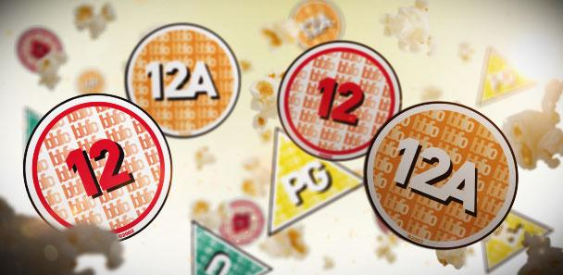
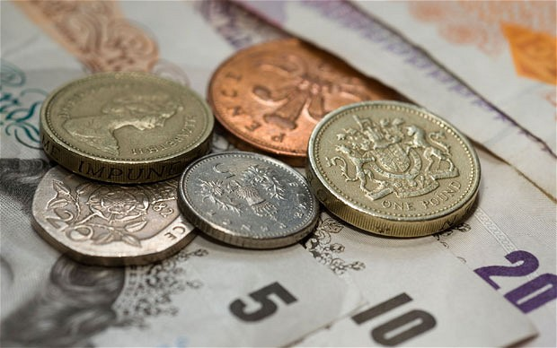
Maths is for life...
... not just for school!

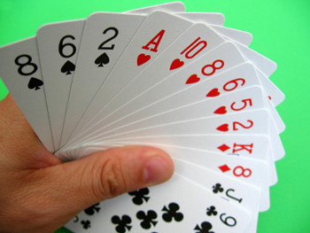

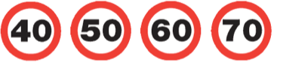
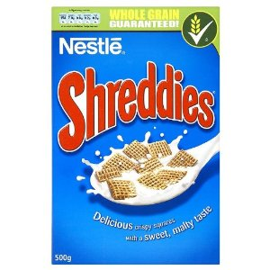
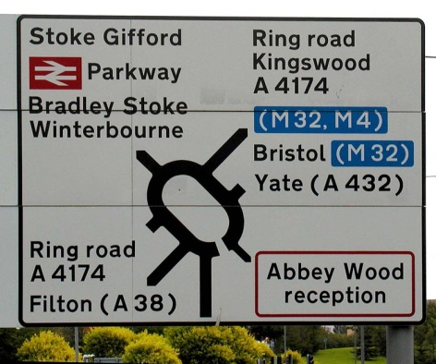
Maths activities to try at home.

Maths is all around us and is a necessary life skill, rather than a subject that is just taught at school. It’s easy for you to help your child/children see this, in lots of different ways.

The ideas in this booklet should act as a starting point for you and your child/children. Some activities are repeated for different year groups, as all children progress at different speeds. There are no rules to how many of these activities you should be attempting. Be led by your child’s levels of enthusiasm and interest. The aim should be for them to learn without even realising they are doing so!

Numbers can be found in the most unlikely of places and children can soon become obsessed with spotting them when they are at home, or when they are outside. Car registration number plates, prices on shelves in the supermarkets, remote controls, phones, speed limits, page numbers in books and magazines... the list goes on and on! Maybe you could take photos and make a poster to display on the wall at home, or share it with your child’s class teacher.

Even if the numbers that are spotted are larger than those they may be learning about at school, don’t discourage them from trying to understand and recognise them! It will help them realise that there is always more to learn about Maths and that numbers just go on and on!

How Maths works in your child’s class.

Reception
In Panda class, the teaching of Maths is split into two main areas; Number and Shape and Space. Children are taught maths through adult-led lessons and are also encouraged to reinforce their learning through activities they choose themselves.

Key Stage 1
In Year 1 and 2, Maths is split into different areas; Number & Place Value, Addition & Subtraction, Multiplication & Division, Fractions, Measures and Geometry (Shape and Position). Children in Year 2 also cover Statistics. Adult-led lessons are the main focus in these classes, although children are also given the opportunity to choose independent activities that involve maths.

As a school, we hope that children enjoy maths and feel confident in their abilities. In order to do this, lessons and activities are carefully planned to ensure that their knowledge is being stretched and developed at a rate that they are comfortable with. Choose activities that your child enjoys and be led by their understanding. Remember these are only ideas and are not intended to be hard work or stressful...

Number and Place Value
This includes:
- recognition of numbers;
- counting;
- comparing numbers and ordering them;
- understanding place value (e.g - 5 always comes after 4 , 25 is 2 lots of ten and 5 ones)
Children need the number names repeated and reinforced in different situations to help them understand that they are always in the same order and that 5 + 3 will always equal 8 for example. They also need to be able to know that 10 is a larger number than 3 and why we know this.
Reception
- count how many steps it takes to get to the car; to bed; to the shop, etc;
- count buses or trees or particular colours of cars while you are out;
- count objects at home (toys when they are tidying away; numbers of DVDs on a shelf; how many spoonfuls of tea they eat);
- Compare amounts of food e.g. who has the most chips or baked beans or orange smarties;
- Find numbers in the environment (road signs, speed restrictions on the road, on food boxes, shop signs, DVD boxes, phone numbers on vans etc, etc).
- Talking about one more (or less). If I have one more or one less potato than you, how many do I have, etc, etc;
- Counting from 1 – 20 and asking which number is one more or one less.

Year 1
- Counting steps on journeys;
- Find numbers in the environment (road signs, speed restrictions on the road, on food boxes, shop signs, DVD boxes, phone numbers on vans etc, etc);
- playing board games like Snakes and Ladders, Ludo, Frustration, etc, etc;
- Talking about one more (or less). If I have one more or one less potato than you, how many do I have, etc, etc;
- Writing numbers from 1 – 20 in numbers and words.

Year 2
- Counting objects in groups of 2, 3 and 5 from 0.
- Counting steps if each step has a value of 2 or 3 or 5.
- Identifying numbers up to 100 in the environment (distances on motorway signs, amounts in recipes.

Calculating ( + and –)
This also includes:
- Number bonds to 20 (pairs of numbers that make 20)
By the time they leave Reception, children should be able to …….; by the end of Year 1, they should be confident in adding and subtracting numbers to 20 and by the end of Year 2, children should be able to add and subtract in a variety of different ways, including +/- two two-digit numbers, +/- a two-digit number and a single digit number and +/- a two-digit number and a multiple of 10.
Reception
- Adding together two quantities, for example the amount of potatoes on two plates; how many bars of chocolate there are in the cupboard; how many apps there are on Mum and Dad’s phones;
- Taking away one single digit number from another (If I have 7 apples and we eat 4 for lunch, how many will there be left over?).
Year 1
- Tidy the shoe cupboard. If there are 12 shoes, how many will I need to make 20.
- If there are 20 biscuits in a packet and we’ve eaten 8, how many will there be left?
- Talking about one more (or less). If I have one more potato than you etc, etc.
- Writing numbers from 1 – 20 in numbers and words.
Year 2
- Comparing numbers of Pokemon cards owned and finding the difference.
- Finding the difference in points between the top and bottom club in the Premier League (or lower leagues!).
- Adding together the number of steps an adult takes on a walk and how many a child takes.

Calculating ( x and ÷) – Year 2 only
This includes:
- Knowing multiplication (x) and division (÷) facts for 2, 5 and 10 multiplication tables.
- Recognising odd and even numbers.
Year 2
- CD of multiplication songs;
- Putting objects into group of 2, 5 or 10 (get them to pair up socks!);
- Looking at house numbers and guessing those that don’t have house numbers.
- Picking out house and stating which times table it belongs to? E.g. “We live at number 10, which is the same as 5 x 2, or 10 x 1”.
Shape, Space and Measure
Although this is a large area of maths, it is also relatively easy to encourage your children to notice how we are surrounded by shapes and measures every day.
This includes:
- Showing an interest in the shape of objects;
- Noticing differences in shapes (a 2p coin and a road sign are very different in size, but they are both circles, a square and a rectangle both have 4 sides, but all the sides of a square are equal in length);
- Recognising 2-d and 3-d shapes;
- Understanding that we can measure time, weight, length, liquids, money and that there are different words to describe all of these.
Reception
- Recognise rectangle, circle, triangle and square;
- Make cookies and cut into different shapes;
- Build models using Lego or similar;
- Go on a shape hunt around the house or outside;
- Hunt out different shaped food boxes in the supermarket or at home;
- Talk about the position of clothes or objects at home;
- Measure parts of body and compare with other members of the family;
- Grow sunflowers or other plants and regularly measure them;
- Weigh out ingredients when cooking;
- Playing with different jugs, bottles etc at bathtime;
- Compare packet sizes in the supermarket;
- Having a clock in their bedroom to know what time they get up;
- How many times can they do an activity (like jump on the spot) in a minute;
- Time how long it takes them to do things like get dressed.

Year 1
As Reception and
- Recognise 2-d shapes (circle, triangle, square, rectangle, hexagon) and 3-d shapes (cube, cuboid, pyramid, sphere, cone, cylinder);
- Comparing weights on packets of food;
- Talk about which objects are heavier or lighter, e.g. Which feels heavier, the apple or the banana? Mum’s ipad or Dad’s book?;
- Recording their height over a period of time and noticing how it changes;
- Talk about time, using the language of o’clock and half past;
- Talk about what time favourite TV programmes start and finish;
- Have a calendar up and record important events and countdown how many days until they happen;
- Look at TV guides to see when favourite programmes are on;
- Recognise different coins and notes and reinforce that the coins can be added together to make different amounts (20p is the same as 10p + 10p in the same way that 20 = 10 + 10);
- Talk about the price of objects in shops;
- Let them pay and get change when shopping;
- How much is your hand worth? Cover your hand with 1p coins, 2p coins etc and see whose hand in the family is worth the most;
- Give (or make them earn) pocket money and talk about what we mean by saving money. Then once they have saved some money, take them shopping to see how quickly it gets spent!
Year 2
As Reception and Year 1 and
- Recognise further 2-d (pentagon, hexagon, heptagon, octagon and semi-circle) and 3-d (triangular prism, square-based pyramid and triangular-based pyramid) shapes;
- Estimate whose step is longest, whose apple weighs most, whether today is warmer than yesterday;
- Set up a simple rain catcher in the garden to measure capacity;
- Look at weather websites to see how temperatures change throughout the day;
- Understand the symbols of £ and p and recognise them on websites or in shops;
- Go shopping and compare prices and offers (like 3 for 2, or buy one, get one free);
- Check they have been given the correct amount of change;
- Use coins to reinforce counting in 2s, 5s, 10s etc;
- Know what happens at certain times of the day (what time they leave for school, what time they have tea, what time clubs they go to start and finish).

Number Activities
Children love showing off what they know! Encourage them to reinforce facts they have learnt at school with open ended questions and activities like the ones below. You can scale the numbers up or down depending on your child’s understanding.
- Tell me everything you know about the number 10, e.g. – It is one more than 9; it is one less than 11; it can be halved to make 5; if you double it, it makes 20 etc, etc.
- Roll 3 dice – who can score the highest; the lowest; who can score closest to 10? or to 8?. How many different ways can you score 8? or 12?
- Use a pack of playing cards and turn over two cards at a time. Can you add or subtract or multiply them?
- If 20 is the answer, what is the questions? e.g. 10 + 10, 20 + 0, 4 + 4 + 12, 30 – 10, 2 x 10, 8 + 8 + 4 etc, etc.

