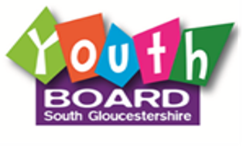
Criteria: Young people who attend a school in South Gloucestershire. School Years 6-11.
Meeting: Online fortnightly Tuesday and physical meet ups ADHOC and during the holidays.
Offer: Hoodie, top and opportunities to win prizes.
Aim:
- To meet other young people and group work skills.
- Create changes for other young people through project work.
- Develop skills in chairing, debating, discussions, art, and consultation work.
Current projects: Youth services and mental health.

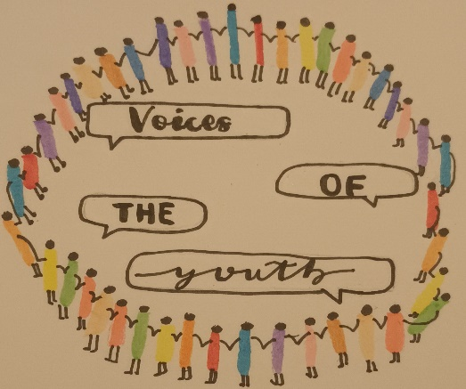
ME.FA Minorities, Equality For All.
Criteria: Young people who attend a school in South Gloucestershire. School Years 6-11. Young people who identify as being ethnic minority. Young people are required to join the Youth Board as well as this forum. This project is a bespoke project of the Youth Board.
Meeting: Online fortnightly Tuesday.
Aim:
- To meet other young people and discuss topics which matter to young people.
- To design a presentation and deliver this to professionals.
- To create a survey for the Race Equality in Education Task Force.


SEND Help and Doughnuts
Criteria: Young people who live South Gloucestershire. School Years 6-11. Young people who identify as having special educational needs.
Meeting: Online fortnightly Tuesday during the winter months and physical meetings during the summer month. Free trips during the half term.
Offer: Will have hoodies once the logo has been designed. Prizes to be won.
Aim:
- To talk about our day.
- To complete the young inspector’s programme.
- Develop group work skills.

Next steps

Young people, carers / parents, teacher can email vanessa.parkhill@southglos.gov.uk with:
- Young person’s name
- School and year group (if known).
- Email address of parent / carer or young person.
- Additional needs (if known)

Vanessa will be able discuss the group options with the young person or parent / carer.

