What is PSHE Education?
PSHE Education (Personal, Social, Health and Economic Education) is a planned programme of learning through which children and young people acquire the knowledge, understanding and skills they need to successfully manage their lives – now and in the future. As part of a whole-school approach, PSHE Education develops the qualities and attributes pupils need to thrive as individuals, family members and members of society.
What do schools have to teach in PSHE Education?
According to the National Curriculum, every school needs to have a broad and balanced curriculum that:
• promotes the spiritual, moral, social, cultural, mental and physical development of pupils at the school;
• prepares pupils at the school for the opportunities, responsibilities and experiences of later life;
• promotes British values.
From September 2020, primary schools in England also need to teach Relationships and Health Education as compulsory subjects and the Department for Education strongly recommends this should also include age-appropriate Sex Education.
Schools also have statutory responsibilities to safeguard their pupils (Keeping Children Safe in Education, DfE, 2019) and to uphold the Equality Act (2010).
The Jigsaw Programme supports all.
What is Jigsaw, the mindful approach to PSHE, and how does it work?
Jigsaw is a whole-school approach and embodies a positive philosophy and creative teaching and learning activities to nurture children’s development as compassionate and well-rounded human beings as well as building their capacity to learn.
Jigsaw is a comprehensive and completely original PSHE Education programme (lesson plans and teaching resources) for the whole primary school from ages 3-11 (12 in Scotland). Written by teachers and grounded in sound psychology, it also includes all the statutory requirements for Relationships and Health Education, and Sex Education is also included in the Changing Me Puzzle (unit).
Jigsaw has two main aims for all children:
• To build their capacity for learning
• To equip them for life
Jigsaw brings together PSHE Education, compulsory Relationships and Health Education, emotional literacy, mindfulness, social skills and spiritual development. It is designed as a whole school approach, with all year groups working on the same theme (Puzzle) at the same time at their own level. There are six Puzzles (half-term units of work) and each year group is taught one lesson per week. All lessons are delivered in an age- and stage-appropriate way so that they meet children’s needs.
Each Puzzle starts with an introductory assembly, generating a whole school focus for adults and children alike. There is also a Weekly Celebration that highlights a theme from that week’s lesson across the school encouraging children to live that learning in their behaviour and attitudes.

How does Jigsaw work at Barley Close?

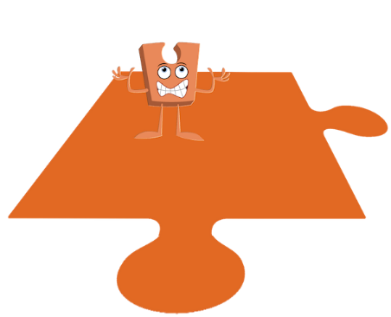
1. Being Me in My World
Includes understanding my place in the class, school and global community as well as devising Learning Charters.
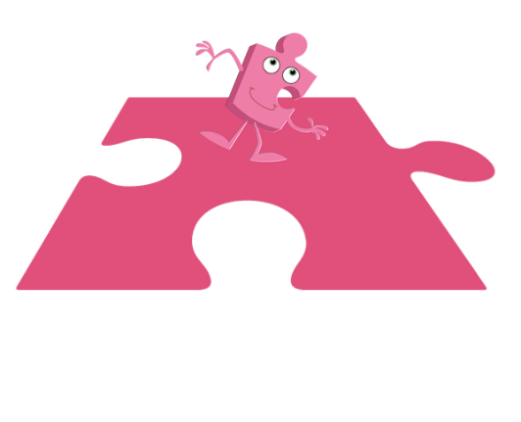
2. Celebrating Difference
Includes anti-bullying (cyber and homophobic bullying included) and diversity work.
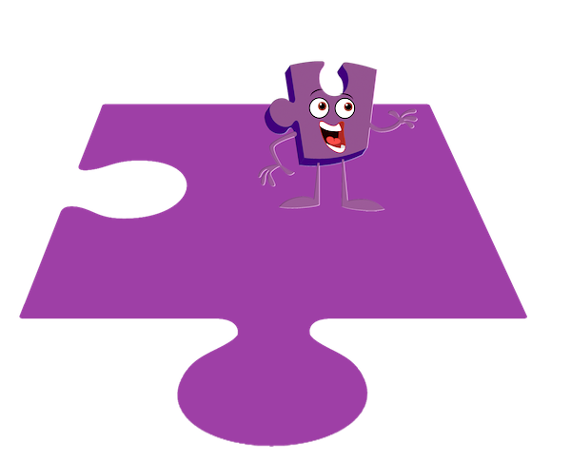
3. Dreams and Goals
Includes goal-setting, aspirations for yourself and the world and working together.
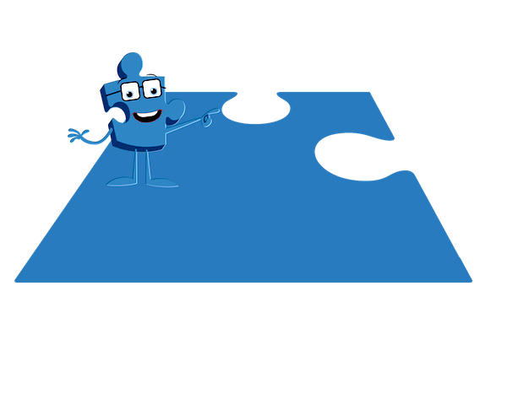
4. Healthy Me
Includes drugs and alcohol education, self-esteem and confidence as well as healthy lifestyle choices.
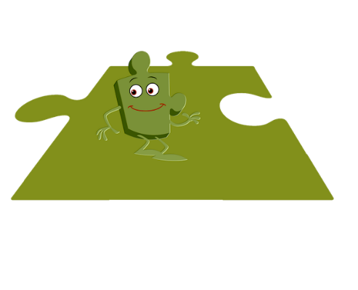
5. Relationships
Includes understanding friendship, family and other relationships, conflict resolution and communication skills.
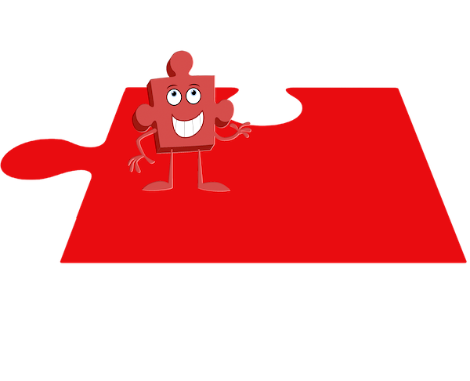
6. Changing Me
This puzzle includes sex and relationships education in the context of coping positively with change. (includes age-appropriate sex education)

Overview of Jigsaw Content by Year Group
- UK-3-11-Snapshot-Overview-Map.pdf

See how Jigsaw fully incorporates the teaching of Fundamental British Values
- UK-British-Values-in-Jigsaw-by-Puzzle-and-Year-Group.pdf

See how Jigsaw lessons create opportunities for developing SMSC
- UK-3-11-SMSC-and-Emotional-Literacy-Mapping-document.pdf

Relationships, Sex and Health Education (RSHE)
- Government Guidance related to Relationships, Sex and Health Education.

See how Jigsaw meets the statutory requirements for Relationships and Health Education
- UK-3-11-and-Statutory-Relationships-and-Health-Education-Map.pdf

RSHE Parent Guide
- RSHE-A-Guide-for-Parents-and-Carers-leaflet-2020.pdf

How LGBTQ content is taught: Parent Guide
- LGBTQ-Parent-Leaflet-A4-2021.pdf

