Online Safety for Parents and Teachers – elevated risks
Online Exploitation and abuse
- The internet has made it easier to build relationships online.
- Offenders can find out a lot about individual children before they make contact by looking at things a child has posted.
- Once an offender has contacted a child on a platform, they can very quickly move from these platforms to a private, unmoderated chat
‘The internet lasts forever’ is a popular saying, but it is not necessarily true – particularly for indecent imagery of children. The internet watch foundation (IWF) can remove criminal content in just two hours. Through engaging with international agencies, they locate the server the image is hosted on, and then take action to remove content.
Child Exploitation and Online Protection Command – CEOP
CEOP is part of law enforcement. It helps keep people safe from sexual abuse and grooming online. CEOP are unable to respond to reports about bullying, fake accounts or account hacking. When you make a report to CEOP it will be read by a Child Protection Advisor, who will get in touch to discuss what you have reported, and what will happen next.








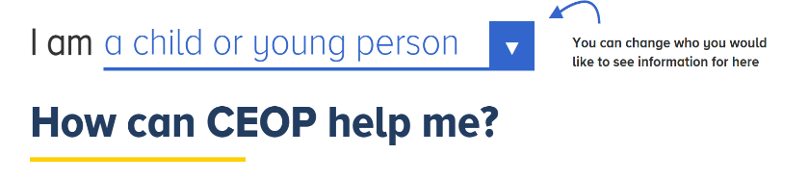
Get support for Online Sexual Exploitation and Grooming:
CEOP – get help and report
MASH – make a safeguarding referral

999 – call 999 if you witness a crime being committed.
Extremist Content Online
The online space has allowed already diverse groups to merge around different issues, as well as accelerating communication and growth. The internet provides extremist groups to reach new audiences and build communities.
Extremist content exists on all social media and gaming platforms. You can report extremist content here.
- Extremist content is often shared through jokes and memes or using references to pop culture. This means that readers can become desensitised to content or interact with content online without knowing it is from an extremist group.
- Extremist content often uses half-truths, fake news, and emotional manipulation to generate attention and interaction.

Get support for Radicalisation and Extremism:
ACT – if you are concerned about a friend or family member you can contact Action Counters Terrorism
MASH – make a safeguarding referral

School – DSL – Prevent. If you are concerned about radicalisation in the school setting please speak to your school’s safeguarding team or report to ACT.
999 – call 999 if you witness a crime being committed.
Risks on most common platforms:

- Roblox, Discord, Steam: multi-platform moderation is hard. Evidence of extremist content and users creating community spaces.
- Whatsapp: Significant disinformation/fake news sharing. Encrypted platform lends to anonymity
- Tik Tok, Twitter, Instagram: Pornographic content, platforms hard to moderate, Twitter algorithms amplify negative voices.
- Youtube: Large platform content moderation nearly impossible. Significant amounts of extremist content. Strong algorithms.

