Year 4 Chameleons and Iguanas
 | Term 1 (8 weeks) | Term 2 (7 weeks) | Term 3 (6 weeks) | Term 4 (5 weeks) | Term 5 (7 weeks) | Term 6 (6.3 weeks)
English | “Wolves in the Wall”  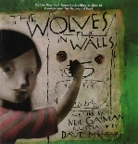  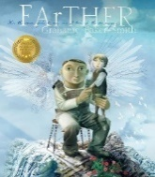  “Farther” | “Kate On The Case”  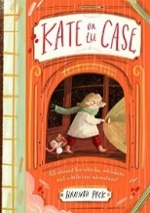 | “Big, Bad Wolf Investigates Fairy Tales”  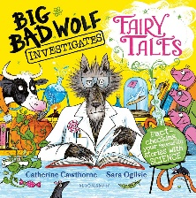 | The Lion, the Witch and the Wardrobe”  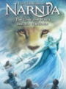 | 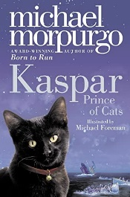  “Kaspar” | “Kensuke’s Kingdom”  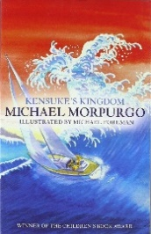
Science | States of Matter | Sound | Electricity | Living things and their habitat | Animals including humans | Science Week
Maths (taught and revisited throughout the year) | - Number and Place Value  - Statistics  - Fractions, Decimals and Percentages  - Measure  - Geometry
Humanities  History, Geography and RE | Ancient Egypt  What does it mean to be a Hindu in Britain today? | UK focus  What does it mean to be a in Sikh Britain today? | The Roman Empire  What can we learn from religions about deciding what is right and wrong? | Map and Fieldwork  Why is Jesus inspiring to some people? | The impact of the Roman Empire on Britain  Why do some people think that life is like a journey and what significant experiences mark this? | Rivers and the Water Cycle  Why do some people think that life is like a journey and what significant experiences mark this?
Art/DT | Art & Design:  Pyramid Sketching- focus on light and shade. | Design & Technology:  Skill:  Skill: Fasteners with running stitch. Use a template.  Product: pencil case/ bag/ purse. | Art & Design:  Exploring Pattern. | Design & Technology: Pizza  Skill: Cooking | Art & Design:  Making Nests | Design & Technology: Lighthouse  Skill: Make an electrical circuit with a bulb- link to Science.  Product: lighthouse.
Music  Kapow Scheme | Body and tuned percussion | Rock and Roll | Adapting and transposing motifs (Theme: Romans) | Haiku, music and performance | Samba and carnival sounds and instruments | Changes in pitch, temp and dynamics (Theme: Rivers)
Computing  Kapow Scheme | Online safety | Programming 1: Further coding with scratch | Computing systems and networks: Collaborative learning | Creating media: Website design | Data Handling: Investigating weather | New Unit: TBC
PSHE | Being me in my world | Celebrating differences | Dreams and Goals | Healthy Me | Relationships | Changing me
PE: | Fundamentals  Coach: Dance | Ball Skills  Mindful Movement | Invasion Games  Hockey  Gymnastics | Basketball  Net Games  Tennis | Football  Coach: Swimming | Rounders  Athletics

