We are all looking forward to the Christmas fair tonight, a huge thank you to FOBC, a small but amazing team of helpers who raise loads of money for our school. They are always looking for new recruits so if you can spare any time, please let us know.
Mrs Jo Williams

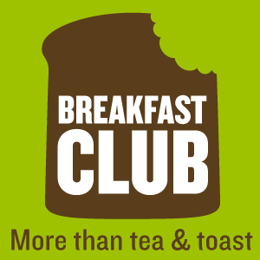 BREAKFAST AND OSC

OSC (Out of School Club) must be pre-booked. If you require a space, please email the office at enquiries@barleyclose.org.uk.

We will also not be open over the Christmas school holidays due to how the festive period and bank holidays land. If you need childcare for February half term, please email the school office by Friday 17 January. Moving forward, we have deadline dates for when bookings can be made. We appreciate things can change at short notice, but we are asking that future bookings are made in advance. Bookings for the Easter holidays need to be made by Monday 10 March, bookings for May half term need to be made by Monday 28 April and for the summer holidays, bookings need to be made by Wednesday 25 June. This allows us to cancel the provision if we do not have the uptake, giving people plenty of notice to find alternative arrangements. The OSC handbook can be found on the website.

Breakfast club is £2 a day per child and does include breakfast. Please pay in advance on Parentpay and state which days you are paying for in the comments box.

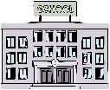 PARENT GOVERNOR
One of our current Parent Governors has completed their 4 year term, it is therefore necessary to readvertise to see if anyone else would like to join us. If you do want to become a school parent governor please contact
jo-marie.williams@barleyclose.org.uk for more information by Friday 29th Nov.
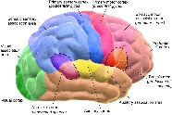NEURODIVERSITY
We are working in partnership with the South Glos Council and South Glos Parent Carers on the 'PINS Project'. This project is funded by the NHS in collaboration with the DfE and will bring investment to our school to help us make the learning environment even more inclusive than it already is.

What is Neurodiversity?

We understand that 'neurodiversity' is not a word that is referred to daily, and we want to keep things as simple as possible so that you're fully aware of how this project will benefit your child and Barley Close’s ability to support them.
‘Neurodiversity’ means that humans are all different in how we think, feel and learn. That’s because all our brains process information in different ways.
Types of neurodivergence include autism, dyslexia, attention deficit disorder (ADHD), Tourette’s syndrome, dyspraxia, dyscalculia, language disorder, social communication disorder and more. Sometimes people can have neurodivergent traits caused by other things.

Back in the summer families, staff, children and governors at our school were asked about our current provision and we have now been able to get support to improve our provision. In the next few weeks we will be working with Jigsaw Thornbury who will be looking at our school environment. People from the Autism education trust will be working with staff to help ensure we give the best support to our neurodiverse children and we will have people looking at the children’s mental health and what we can do to support everyone in our community.

 SCHOOL NEWS

Last week was anti bullying week. The children’s PHSE lessons and assemblies focused on what bullying is and how important it is to tell an adult who can help.

YR 2 and 4 had road safety workshops led by South Glos road safety team.

At parents evening subject leaders had some information on display about our school curriculum. As you know our OFSTED inspection identified we needed to do some more work on assessing our curriculum, this was always the plan to do this during this academic year. We are working with local schools on this and making good progress. Subject leaders are talking to children about their learning and ensuring teachers are teaching what they are asking them to do.

Do you follow a religion? Would you like to share your knowledge and passion of your faith with the children of Barley Close?
If yes, then we would love to invite you into school!
You might want to hold a whole school assembly (or an assembly just for specific year groups), come into class or share some special items that are important to you and your faith.
If you would be interested in supporting the children of Barley Close with their developing understanding of different faiths, please contact Mrs Rammell on the below email address to arrange a visit.
jessica.rammell@barleyclose.org.uk
We look forward to having you in and learning more about the many different religions with our school!

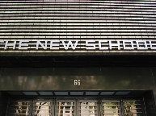 NEW LYDE GREEN SECONDARY SCHOOL

Earlier this term I met the new head of the Lyde Green secondary school, due to open in September 2026. He is keen to involve the community, so I have been asked to pass this link on to you. More updates will be sent through when we get them.

https://sway.cloud.microsoft/mWFpgCAu0NbfQy7k?ref=Link

DATES FOR YOUR DIARY
25 Nov | Flu vaccinations
2 Dec | INSET
11 Dec | Christmas lunch  EYFS and KS1 performance 2pm and 6pm
20 Dec | Pupil of the term  End of term
6 Jan 2025 | Back to school
21 Jan | YR 6 lifeskills
31 Jan 2025 | INSET
14 Feb | Pupil of the term  End of term
24 Feb | Back to school
10 Mar | Class and Y6 leavers’ photos
18 and 20 Mar | Parents’ Evening
4 Apr | Pupil pf the term  End of term
22 Apr | Back to school
5 May | MAY DAY
12-15 May | Year 6 SATS week
19-23 May | Sports week
21 May | Sports day
23 May | Pupil of the term  End of term
2 June | Back to school
2-6 june | Yr 6 camp
9-13 June | Year 1 and 2 Phonics tests
27 June | INSET day
18 July | Pupil of the term
22 July | 9.30 am – Leavers’ assembly  End of term
Term dates 2025 - 2026 | 1.9.25 – 24.10.25  3.11.25 – 19.12.25  5.1.26 – 13.2.26  23.2.26 – 2.4.26  20.4.26 – 22.5.26  1.6.26 – 22.7.26

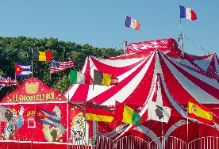 THE CIRCUS IS COMING TO TOWN
On 12th Sept 2025 Happy Circus will be coming to our school field. Tickets will be on sale nearer the time but make a note of the date now!

